Urban Lab Affordable Housing Dashboard: A Data Portal for NYC

Applied Project Final Report

By

Yue Yu

Fall Semester, 2025

A paper submitted in partial fulfillment of the requirements for the degree of

Master of Science in Management and Analytics

at the

Division of Programs in Business

School of Professional Studies

New York University

Table of Contents

Declaration

Acknowledgments

Abstract

Abbreviations And Definitions

1. Introduction 1

1.1 Problem 1

1.2 Approach 1

1.3 Core Technology 2

1.4 Benefits 2

1.5 Research Question 2

1.6 Contribution 3

1.7 Sponsor 3

1.8 Importance Of Project 3

2. Project Objectives And Metrics 4

2.1 Goal of the Project 4

2.2 Project Deliverables and Metrics 4

2.3 Project Evaluation 5

3. Alternate Solutions Evaluated 6

3.1 Solution Evaluation Criteria 6

3.1.1 React frontend with Mapbox GL Js or Leaflet 6

3.1.2 Flask instead of FastAPI for backend services 6

3.1.3 Geopandas for Spatial Processing 7

3.1.4 BI Tools such as Apache Superset or Tableau 7

3.2 Solution Evaluation Criteria 8

3.3 Selection Rationale 8

4. Literature Survey 9

4.1 Introduction 9

4.2 Industry 9

4.3 Problem 10

4.4 Proposed Solution 10

4.5 Technology 11

4.6 Use Cases 11

4.7 Conclusion 12

5. Approach And Methodology 13

5.1 Problem Statement and Research Question 13

5.2 Proof of Concept Approach 13

5.3 Technology Trial Plan 14

5.4 Population/Data 14

5.4.1 Rent Burden 14

5.4.2 Income 15

5.4.3 Market Rent 15

5.4.4 Demographics 15

5.4.5 Geographic Data and Crosswalks 15

5.5 Procedures 16

5.5.1 Data Harmonization via Crosswalks 16

5.5.2 ETL Workflow 16

5.5.3 Database Schema 17

5.5.4 API Architecture 17

5.5.5 Dashboard Visualization 17

5.5.6 Deployment 18

5.5.7 Technology Trial Summary 18

5.6 Organizational Change Plan 18

6. Results 19

6.1 data processing 19

6.1.1 Data acquisition and Initial Cleaning 19

6.1.2 Database Schema Creation 19

6.1.3 ETL Processing using Python + Sql 19

6.1.4 Database-Level Transformations 20

6.2 Outcomes 21

6.2.1 Page 1 - App Page 21

6.2.2 Page 2 - Analysis Page 25

6.2.3 Page 3 - Rent Burden Page 30

6.3 Findings 32

6.4 Summary Statistics 33

6.5 Implications 34

6.5.1 Practical Implications 34

6.5.2 Theoretical Implications 34

6.6 Summary 34

6.7 Repository of Datasets and Code 35

7. Issues Encountered 36

7.1 Data Quality and Inconsistent Formats 36

7.2 Geographic Misalignment between Tract-Level and Zip-Level Data 36

7.3 Sql Table Creation Errors and Cloud Database Upload Failures 37

7.4 Spatial Rendering Issues in Pydeck 37

7.5 Api Connectivity and Deployment Limitations 38

7.6 Project Scope Adjustment 38

7.7 Risk Management Plan 39

8. Lessons Learned 40

9. Conclusion And Further Work 41

9.1 Conclusions 41

9.1.1 Overall Outcomes 41

9.1.2 Key Findings 41

9.1.3 Viability Assessment 41

9.2 Implications 42

9.2.1 Theoretical Implications 42

9.2.2 Practical Implications 42

9.3 Limitations 42

9.3.1 Constraints 42

9.3.2 Validity And Bias 43

9.3.3 Limitations Of Generative AI For Business Process Re-Engineering 43

9.4 Further Work 43

9.4.1 Next Steps 43

9.4.2 Long-Term Directions 44

9.5 Closing Summary 44

References 45

Appendix A - Project Acceptance Document 47

Appendix B - Project Sponsor Agreement 48

Appendix C – Functional Requirements Specifications 54

Appendix D - Project Plan 57

Appendix E - Risk Management Plan 60

Appendix F – Organizational Change Management Plan 63

Appendix G – Technology Trial Plan 66

Appendix H - Status Reports 68

Appendix I - Annotated Bibliography 76

Table of Figures

Figure 6‑1 Introduction of App Page 21

Figure 6‑2 Interactive Map 22

Figure 6‑3 Result 1 of “Search by Project ID” 23

Figure 6‑4 Result 2 of “Search by Project ID” 24

Figure 6‑5 Data Download Function 24

Figure 6‑6 Analysis Dashboard, Value lookup 25

Figure 6‑7 Analysis Dashboard, Most Critical Areas, Outlook 26

Figure 6‑8 Analysis Dashboard, Most Critical Areas, Table Operation 26

Figure 6‑9 Median Rent Map 27

Figure 6‑10 Median Income Map 28

Figure 6‑11Rent Burden Map 29

Figure 6‑12 Rent Burden Dashboard, Summary Statistics 30

Figure 6‑13 Rent Burden Dashboard, Rent Burden Histogram 30

Figure 6‑14 Income Rent Burden Distribution, All Borough 31

Figure 6‑15 Income Rent Burden Distribution, Manhattan 31

# Declaration

I, *Yue Yu*, declare that this project report submitted by me to School of Professional Studies, New York University in partial fulfillment of the requirement for the award of the degree of Master of Science in Management and Analytics is a record of project work carried out be me under the guidance of ***Professor Matthew Kwatinetz, Clinical Assistant Professor, NYU Urban Lab.***

I grant powers of discretion to the Division of Programs in Business, School of Professional Studies, and New York University to allow this report to be copied in part or in full without further reference to me. The permission covers only copies made for study purposes or for inclusion in Division of Programs in Business, School of Professional Studies, and New York University research publications, subject to normal conditions of acknowledgment.

I further declare that the work reported in this project has not been submitted and will not be submitted, either in part or in full, for the award of any other degree or diploma in this institute or any other institute or university.

# Acknowledgments

I would like to sincerely thank Professor Matthew Kwatinetz for his guidance, insights, and ongoing support as the sponsor of this project. His feedback throughout the development of the Urban Lab Affordable Housing Dashboard was invaluable.

I also want to express my appreciation to Professor Andres Fortino and the faculty members in the Management and Systems program. The knowledge and skills gained through my coursework directly shaped the technical and analytical foundations of this project.

Finally, I am grateful to the Urban Lab team for their collaboration and for providing the opportunity to work on a meaningful project with real-world impact.

# Abstract

New York City’s affordable housing data is scattered across multiple public sources, making it difficult for researchers and policymakers to efficiently analyze rent, income, and housing affordability at a consistent geographic scale. This project addresses this problem by developing an integrated and geospatially harmonized data platform—a web-based dashboard—that consolidates income, market rent, rent burden, and affordable housing supply into a single interactive system. The proposed solution combines a spatial PostgreSQL/PostGIS database, a structured data cleaning and integration workflow, and a Streamlit-based visualization interface to create a unified and accessible data environment. The proof of concept aims to demonstrate that fragmented NYC housing indicators can be standardized and delivered through a user-friendly, map-driven interface.

To accomplish this, the project implemented dataset acquisition from public sources, manual and script-assisted cleaning and transformation procedures, geographic crosswalk harmonization, and a spatial database architecture using PostgreSQL/PostGIS. The dashboard visualizes ZIP-level affordability metrics, integrates filtering tools, and provides downloadable datasets for further analysis. A technology trial compared unstructured data handling with the standardized ETL workflow, evaluating improvements in processing consistency, error reduction, and overall analytical reliability.

Results show that the structured ETL workflow significantly improved data consistency, produced harmonized ZIP-level indicators across all datasets, and enabled stable map rendering and responsive querying within the dashboard. These findings confirm that systematic cleaning and geospatial harmonization enhance data reliability and allow clearer insight into affordability disparities across NYC.

The results also indicate that a consolidated geospatial framework can meaningfully improve the usability of open housing data for policy research and planning. Future work may incorporate temporal trend analysis, automated ETL pipelines, predictive modeling, and additional modules such as housing complaints and displacement risk. In the long term, the system can be scaled to other cities and adapted for broader housing policy evaluation. Overall, the project demonstrates a replicable approach to transforming fragmented public datasets into coherent, decision-ready urban analytics tools.

Dashboard URL: <https://becky0713-noah-frontendapp-gehyze.streamlit.app/>

# Abbreviations and Definitions

ACS – American Community Survey. A nationwide annual survey conducted by the U.S. Census Bureau providing demographic, socioeconomic, and housing estimates.

ACRIS – Automated City Register Information System. NYC’s official system for recording property documents, including deeds, mortgages, and transfers.

AMI – Area Median Income. Income thresholds published by HUD and adapted by HPD to determine housing eligibility and affordability brackets.

BBL – Borough Block Lot. NYC’s parcel-level identifier used for tax lots and GIS-based joins.

BIN – Building Identification Number. Unique identifier assigned to each building in NYC’s administrative datasets.

CD – Community District. A sub-municipal geography used by NYC for planning and statistical reporting.

GeoJSON – An open geospatial data format used for representing simple geographic features and their attributes.

GEOID – Census geographic identifier for units such as tracts, block groups, or PUMAs.

HPD – NYC Department of Housing Preservation and Development. Primary city agency for affordable housing programs, data, and regulation.

HUD – U.S. Department of Housing and Urban Development. Federal agency responsible for AMI definitions and affordable housing policy.

LION / PAD – NYC street centerline and address datasets used for geocoding and spatial normalization.

NOAH – Naturally Occurring Affordable Housing. Unsubsidized housing units that remain affordable to low- and moderate-income households.

PLUTO – Primary Land Use Tax Lot Output. NYC’s comprehensive parcel database combining land use, building, zoning, and assessment attributes.

PostGIS – Spatial extension of PostgreSQL supporting geometry storage and geospatial queries.

REST API – Representational State Transfer Application Programming Interface. A standardized web service approach for exchanging structured data.

Rent Burden – Percentage of household income spent on gross rent. Spending 30 percent or more indicates burden; 50 percent or more indicates severe burden.

Three.js – JavaScript library enabling WebGL-based 3D visualization.

311 Complaints – NYC’s public reporting system for service issues, often used as indicators of housing quality or access.

# Introduction

Affordable housing has long been a central policy concern in New York City, where rising rents, uneven income growth, and aging housing stock place increasing pressure on lower- and moderate-income households. While the city makes extensive public data available through platforms such as NYC Open Data, ACRIS, HPD, and the U.S. Census Bureau, researchers often need to assemble multiple sources to understand affordability conditions across neighborhoods. Each dataset follows its own structure, update cycle, and geographic unit, which requires substantial preprocessing before analysis can begin.

In academic and policy literature, reliable affordability indicators—such as rent burden, market rent patterns, income levels, demographic characteristics, and basic housing stock attributes—are widely recognized as essential for evaluating neighborhood-level housing conditions. However, constructing these indicators typically involves repetitive and time-intensive data wrangling efforts that divert attention from substantive research questions.

## 1.1 Problem

Although relevant datasets are publicly available, they are highly fragmented across agencies and systems. As a result, researchers must manually locate, download, clean, and reconcile information from numerous sources before conducting even routine analysis. This fragmented landscape increases the cost of research, introduces inconsistencies across projects, and limits the ability of the Urban Lab to respond quickly to emerging policy questions.

What is lacking is a single, consolidated platform that brings together the datasets most frequently used to study naturally occurring affordable housing (NOAH) in NYC and presents them in a consistent, well-documented, and interactive format. Without such a platform, analysts repeatedly rebuild similar pipelines—an inefficient and error-prone process that slows the production of reliable insights.

## 1.2 Approach

This project develops a unified NOAH data dashboard that integrates key housing and socioeconomic datasets into a centralized, spatially enabled environment. The system automates data ingestion, harmonizes geographic identifiers, stores standardized datasets in a relational spatial database, and provides a web-based interface for interactive exploration. The dashboard organizes indicators into intuitive thematic groups—such as Rent Burden, Market Rent, Income, Housing Stock, and Demographics—mirroring the analytical structure commonly used by policymakers and researchers.

The platform enables users to visualize spatial patterns, filter data by geography or attributes, and export customized datasets for further analysis. In doing so, it replaces the need for repetitive manual data preparation with a stable, reusable, and transparent analytical foundation.

## 1.3 Core Technology

The solution uses a modern full-stack architecture:

* **PostgreSQL/PostGIS** for spatial data storage, querying, and indexing
* **Python (Pandas)** for automated ETL pipelines and data standardization
* **REST API built with FastAPI** to serve housing project data for the interactive map **Streamlit with PyDeck** to provide an interactive, map-first user interface
* **Cloud deployment via Docker, Render, and Streamlit Cloud** for scalability and reliability

This technology stack was selected for its simplicity, interoperability, and strong practical alignment with the Urban Lab’s analytical workflows.

## 1.4 Benefits

The dashboard offers several advantages to the Urban Lab:

1. **Centralization** of commonly used NOAH-related datasets in one platform
2. **Reduced research overhead** by automating data ingestion and standardization
3. **Consistent geographic crosswalks** enabling reliable neighborhood-level comparisons
4. **Interactive visualizations** that make patterns easier to interpret
5. **Reproducible outputs** through documented schemas and API-based access

Together, these benefits strengthen the Lab’s analytical capacity and support faster, more transparent decision-making.

## 1.5 Research Question

This proof of concept investigates the extent to which a unified data dashboard can reduce the time, analytical complexity, and inconsistency typically associated with examining naturally occurring affordable housing in New York City.

The inquiry is guided by the following subsidiary questions:  
1. To what extent can structured data pipelines streamline and accelerate data preparation?  
2. How effectively can heterogeneous public datasets be harmonized within a single spatial database framework?  
3. Which forms of visualization and interactivity provide the greatest analytical value for NOAH-focused research and decision-making?

## 1.6 Contribution

This proof of concept contributes a unified and reproducible architecture for analyzing naturally occurring affordable housing in New York City. It consolidates multiple fragmented public datasets into a standardized PostgreSQL/PostGIS environment, supported by a Python-based ETL workflow and a FastAPI service layer for selected housing project data. The project also delivers an accessible Streamlit and PyDeck interface that enables spatial exploration of key affordability indicators. Together, these components demonstrate a scalable, transparent, and methodologically consistent framework that can serve as a foundational data infrastructure for future Urban Lab research.

## 1.7 Sponsor

The project is sponsored by Professor Matthew Kwatinetz, Clinical Assistant Professor at the NYU Urban Lab. The Lab focuses on applied research in housing, economic development, and urban systems, and relies heavily on integrated, high-quality datasets to support internal research and external partnerships.

## 1.8 Importance of Project

For the Urban Lab, a consolidated NOAH dashboard directly advances its mission of promoting data-driven urban research. By reducing the time spent locating and preparing data, the platform enables researchers to focus on substantive analysis and provides a durable foundation for future modeling efforts, scenario testing, and collaborations. The dashboard will also facilitate more consistent and transparent evaluation of affordability challenges across NYC neighborhoods.

# Project Objectives and Metrics

## 2.1 Goal of the project

The goal of this project is to develop a unified, interactive data dashboard for the NYU Urban Lab that consolidates publicly available affordable housing and socioeconomic datasets relevant to naturally occurring affordable housing (NOAH) in New York City. The dashboard aims to provide a centralized, reproducible, and user-friendly platform for exploring spatial patterns, generating standardized indicators, and exporting clean datasets for further analysis.

## 2.2 Project Deliverables and Metrics

**Project Objective 1:** Data Aggregation and Standardization

Objective: Integrate multiple NYC and federal datasets into a centralized PostgreSQL/PostGIS database with consistent schemas and geographic identifiers.

Metric: At least five datasets successfully ingested, cleaned, and standardized, with validated GEOID, tract, and BBL alignment.

**Project Objective 2:** Database Structure & SQL Modeling

Objective: Build a structured PostgreSQL (dataset)/PostGIS (extension of PostgreSQL) database to support indicator generation and spatial queries.

Metric: Relational schema with rent, income, burden, and housing supply tables, plus SQL models for ZIP-level aggregation.

**Project Objective 3:** Backend REST API

Objective: Build a FastAPI service layer that exposes cleaned and standardized datasets for programmatic access.

Metric: Functional API endpoints for spatial and attribute-based queries demonstrated, with auto-generated documentation via OpenAPI.

**Project Objective 4:** Interactive Dashboard Interface

Objective: Create a Streamlit-based front-end portal with PyDeck visualizations and indicator panels.

Metric: An MVP dashboard featuring at least two spatial layers and interactive map exploration delivered.

**Project Objective 5:** Deployment and Documentation

Objective: Deploy the complete system—including backend, database, and frontend—to cloud platforms with clear user documentation.

Metric: Fully deployed platform and documentation package (user manual, API guide, and final report) submitted.

## 2.3 Project Evaluation

Project success was evaluated based on completion of the objectives and metrics established at the beginning of the semester and agreed upon by the sponsor. Evaluation factors included:

* Successful integration of targeted datasets into the centralized database
* Verified reduction in data-update time through structured ETL workflows
* Functionality and stability of FastAPI endpoints serving housing project data
* Usability and responsiveness of the Streamlit dashboard
* Accurate deployment and completeness of documentation

These criteria align with the final acceptance requirements approved by the project sponsor.

# Alternate Solutions Evaluated

Several alternative tools and architectures were evaluated before selecting the final implementation stack. These alternatives represented commonly used options in urban analytics and civic-tech applications but were ultimately not chosen due to development constraints, complexity, or limited alignment with project goals.

## 3.1 Solution Evaluation Criteria

### ****3.1.1 React Frontend with Mapbox GL JS or Leaflet****

A full custom frontend using React paired with Mapbox GL or Leaflet was considered.  
**Advantages:**

* High flexibility in UI/UX design
* Widely used for production-grade mapping applications
* Strong ecosystem for custom layers and animations

**Limitations:**

* Requires substantial JavaScript development time
* Higher maintenance overhead
* Not aligned with the capstone timeline for solo development
* Requires parallel frontend–backend integration work

Because the goal was to rapidly prototype a functional, research-oriented dashboard rather than build a fully custom web app, this option was not selected.

### ****3.1.2 Flask Instead of FastAPI for Backend Services****

Flask was initially considered because of its simplicity and wide adoption.  
**Advantages:**

* Lightweight and flexible
* Large community and documentation

**Limitations:**

* Lacks built-in async support
* No automatic schema validation
* No automatic OpenAPI documentation

Given the need for clean, documented, and scalable REST endpoints, **FastAPI offered superior performance and easier maintainability**, leading to its selection.

### ****3.1.3 GeoPandas for Spatial Processing****

GeoPandas was evaluated as an ETL option for directly manipulating geometries in Python.  
**Advantages:**

* Intuitive geospatial data manipulation
* Good for exploratory analysis

**Limitations:**

* Slow with large NYC-scale datasets
* Less efficient than pushing geometry handling to PostGIS
* Adds unnecessary overhead to ETL pipeline

Because all spatial operations could be delegated to the PostGIS backend, GeoPandas was not adopted.

### ****3.1.4 BI Tools Such as Apache Superset or Tableau****

Superset and Tableau were briefly considered as alternatives for visualization.  
**Advantages:**

* Easy dashboard creation
* Built-in filtering and exploration
* No need to build low-level UI

**Limitations:**

* Limited geospatial customization
* Less control over indicator logic
* Not ideal for API-driven or programmatically reproducible workflows
* Harder to integrate with automated ETL pipelines

Since the dashboard required custom, map-first exploration with consistent schema control, BI tools were not chosen.

## 3.2 Solution Evaluation Criteria

To evaluate and compare options, several criteria were established at the beginning of the project:

1. **Time Feasibility**  
   Given the semester timeline, the solution needed to enable rapid prototyping while maintaining technical rigor.
2. **Technical Simplicity and Maintainability**  
   Urban Lab researchers should be able to extend or maintain the system with minimal onboarding.
3. **Data Reproducibility**  
   The platform needed to support standardized schemas, geographic keys, and consistent ETL logic.
4. **Scalability and Transparency**  
   The solution should support future datasets and analytical modules without major redesign.
5. **User Accessibility**  
   The interface should be easily accessible to researchers without requiring front-end development experience.

## 3.3 Selection Rationale

After evaluating alternatives, the chosen architecture—**PostgreSQL/PostGIS + Python (Pandas) + FastAPI + Streamlit/PyDeck + Render/Streamlit Cloud**—was selected because it best met the project’s goals:

* **Fast prototyping** with Streamlit allowed all focus to be placed on data integrity and spatial analysis rather than UI engineering.
* **FastAPI** provided clean, automatically documented endpoints and strong performance.
* **PostGIS** handled all spatial joins and indexing efficiently, reducing ETL code complexity.
* **Pandas-based ETL** workflows minimized overhead and kept the data transformation process clear and reproducible.
* **PyDeck** offered robust geospatial visualization without requiring JavaScript.
* **Docker-based deployment for the backend and cloud hosting for both services ensured reproducibility and simplified environment setup.**

Collectively, these tools aligned with the Urban Lab’s need for a transparent, extensible, and data-first platform while remaining achievable within the capstone timeline.

# Literature Survey

## 4.1 Introduction

This literature review supports a focused proof of concept for the **NOAH (Naturally Occurring Affordable Housing) Dashboard for NYC**. The tool’s primary goal is clear, trustworthy presentation of affordable housing data with lightweight, interpretable analysis, no predictive modeling or complex welfare simulations. Indicators are organized around six practical analytical dimensions that mirror the way housing stakeholders already discuss needs and trade-offs. These dimensions include Rent Burden, Market Rent, Income, Housing Stock, Demographics, and Access and Complaint Data.

The review synthesizes literature that (a) establishes why these six dimensions matter for affordability monitoring, (b) documents common data and crosswalk challenges in NYC, and (c) supports a simple, standards-based stack (PostgreSQL, Python ETL, and React) to publish maps, tables, and downloadable datasets. Health and welfare findings appear only as background motivation for why rent-burden and access indicators are policy-relevant, not as features the tool must compute. The chapter is organized thematically into the following sections: Industry, Problem, Proposed Solution, Technology, Use Cases, and Conclusion. For grounding, this chapter draws on Meltzer and Schwartz (2016) for NYC rent‑burden measurement; Boeing and Waddell (2017) for listing‑based asking‑rent indicators; Ambrose, Coulson, and Yoshida (2015) for quality‑adjusted rent indexing; Sieg and Yoon (2019) for access frictions; Schwartz (2019) for NYC policy context; Zapatka, de Castro, and Galvão (2023) for rent stabilization; Desmond and Wilmers (2019) for price setting in low‑income markets; and Fields and Uffer (2014) for financialization dynamics.

## 4.2 The Industry

The U.S. rental market has experienced persistent affordability stress, with cost‑burden rates particularly acute in large metros such as New York City. Across major cities, supply constraints, aging housing stock, and uneven income growth have increased the share of renters spending at least thirty percent of income on housing (Colburn & Allen, 2018). In New York City, measured rent‑burden disparities align with neighborhood income patterns and with differences in access to opportunities (Meltzer & Schwartz, 2016). A second strand of work shows that price signals from listings illuminate local dynamics when interpreted carefully (Boeing & Waddell, 2017), and that quality‑adjusted rent indexing helps separate composition from true price change (Ambrose, Coulson, & Yoshida, 2015). Allocation institutions also matter; queueing and search frictions are first‑order features of how households obtain regulated or subsidized units in the city (Sieg & Yoon, 2019). Finally, policy context shapes observed outcomes, including the role of rent stabilization and who benefits from it (Schwartz, 2019; Zapatka, de Castro, & Galvão, 2023). Concurrently, cities have embraced urban informatics, the systematic use of open administrative and survey data to inform planning, although platforms vary in usability and interoperability (Schwartz, 2019). The literature underscores that integrated, standards-based data portals can reduce transaction costs for policy analysis and stakeholder engagement in housing.

A second stream of industry literature tracks housing production, preservation, and naturally occurring affordable housing, defined as unsubsidized units affordable to lower‑ and moderate‑income households. In New York City, reviews of programs and policy changes document how preservation tools, code enforcement, and acquisition can stabilize affordability in gentrifying areas when guided by timely parcel‑level information and inter‑agency coordination (Schwartz, 2019). Comparative work further cautions that financialization pressures can reshape rental markets and the composition of stock (Fields & Uffer, 2014). For NYC, administrative datasets such as HPD, DOB, and DOF or ACRIS, as well as federal sources such as the ACS, are foundational yet siloed. This complicates efforts to monitor loss of affordability, track capital needs, and align subsidy programs with neighborhood trajectories. For NYC, administrative datasets such as HPD, DOB, and DOF or ACRIS, as well as federal sources such as the ACS, are foundational yet siloed. This complicates efforts to monitor loss of affordability, track capital needs, and align subsidy programs with neighborhood trajectories.

Finally, industry research on climate and resilience links housing vulnerability to flood risk, heat exposure, and building energy performance. Integrating resilience layers with affordability metrics enables more holistic risk-benefit assessment for investments and tenant protection policies. Actionable platforms must support spatio-temporal analysis, such as changes in flood maps, capital improvements, or 311 complaints over time, while remaining interpretable for nontechnical stakeholders. These demands shape the requirements for the NOAH Dashboard’s indicator design and map interactivity.

## 4.3 The Problem

Despite a wealth of NYC open data, fragmentation, inconsistent schemas, and limited crosswalks impede synthesis across housing, demographics, resilience, and service-access indicators. Researchers frequently duplicate ETL work, while versioning and refresh cadences differ by source, reducing reproducibility. Critical measures such as rent burden, code violations, and foreclosure signals exist at mismatched geographies, including tract, PUMA, community district, and BIN or BBL, as well as at different time scales, complicating comparisons or longitudinal analysis. Visualization tools often hard-code layers without standardized metadata, hindering discoverability and quality control. Consequently, policy and academic users face high transaction costs to assemble decision-ready views for neighborhoods, leading to delays and inconsistent evidence bases.

## 4.4 Proposed Solution

The proposed solution is an open, modular, standards-oriented dashboard that ingests authoritative public data via automated pipelines, harmonizes geographies with robust crosswalks (for example, BBL to tract to community district), stores spatial data in PostgreSQL or PostGIS with provenance and versioning, exposes documented REST APIs for external reuse, and renders interactive visualizations using Mapbox GL or Leaflet and Three.js with multiple layers and time controls. Prior work shows that such architectures improve data reuse, transparency, and policy uptake when coupled with clear metadata and user-centered design. Relative to current NYC portals, the NOAH Dashboard’s contribution is a unified, NOAH-focused indicator model paired with reproducible pipelines and open services, enabling academics and agencies to share a common analytical foundation.

## 4.5 The Technology

A relational spatial design in PostgreSQL supports geometry types, parcel polygons, and building footprints, along with indices for efficient geospatial queries. Normalized core tables, including parcels, buildings, rent burden, complaints, sales, and permits, link through durable keys such as BBL and BIN and maintain provenance columns, including source ID, snapshot date, and transform hash. Materialized views precompute common joins, such as parcel to tract to district, and indicator summaries to accelerate map rendering.

ETL is implemented in Python with Pandas, orchestrated by a lightweight scheduler such as cron or GitHub Actions or a workflow tool such as Prefect. Crosswalks, including Census GEOIDs, NYC PLUTO, LION, and PAD, are versioned to ensure reproducibility when boundaries change. Metadata follows a simplified Frictionless Data pattern using resource descriptors, schemas, and data dictionaries. APIs adhere to REST conventions with OpenAPI documentation, rate limits, and token authentication. Geospatial endpoints return GeoJSON or PMTiles for efficient web maps.

The front end uses React with Mapbox GL or Leaflet for vector-tile rendering and a Three.js layer for 3D context, such as extruded buildings and energy or age shading. The user interface emphasizes map-first exploration with side-panel legends, filters, and time sliders. Accessibility and performance are addressed through progressive loading, tile caching, and WebGL instancing. Empirical studies report that multiscale visualization with clear legends and uncertainty cues improves interpretability for nonexperts, especially when paired with scenario narratives and export functions.

Cloud deployment on AWS or GCP hosts the API and tile server. Database backups and row-level security protect restricted tables if needed. Observability includes structured logs and metrics such as latency, error rates, and ETL freshness. Versioned releases and a change log support academic citation of specific data snapshots.

## 4.6 Use Cases

**Use Case 1: Neighborhood affordability snapshot.** Users choose a geography, such as a tract or community district, and view a concise panel showing rent-burden distribution, median market rent (asking), income percentiles compared with AMI, stock age or tenure mix, and a rolling count of 311 heat or hot-water complaints. This consolidates scattered sources into a single screen without advanced modeling.

**Use Case 2: Simple trend and comparison.** Users toggle a time slider to see market-rent trends and rent-burden changes and to compare two neighborhoods side by side. The portal provides clear caveats, including asking rent versus signed lease, geographic definitions, and data vintages.

**Use Case 3: Quick download for analysis.** With one click, users export a tidy CSV or GeoJSON file for any selected area, including standardized keys such as GEOID and BBL or BIN, so analysts can join to external models.

## 4.7 Conclusion

The literature supports a lean, standards-based portal that harmonizes NYC housing data across the six dimensions above and improves transparency with minimal computational burden. Rather than forecasting outcomes, the dashboard’s value proposition is to reduce transaction costs for routine questions such as “What are rent-burden levels here?” “How do asking rents compare across neighborhoods?” and “What stock characteristics or complaint patterns coincide with higher burden?” while documenting data lineage and caveats. This scoped approach aligns with evidence that interoperability, clear metadata, and simple visualizations increase uptake by policy and community users. The chapter therefore justifies proceeding with a lightweight MVP centered on presentation, standard joins, and basic descriptive statistics, leaving advanced analytics to external tools that can reuse the portal’s clean outputs.

From these examples and existing literature supporting this application, we conclude that a standards-based, open, and modular spatial data portal can substantially reduce the time and expertise required to assemble decision-ready NOAH insights in NYC. Specifically examining the intersections of affordability, stock condition, service access, and resilience, the literature supports harmonized geographies, reproducible ETL, and programmable APIs as enabling conditions for rigorous evaluation and collaboration. Most of the literature reviewed concluded that transparency, interoperability, and user-centered visualization increase uptake of evidence in policy and research, outcomes aligned with the NOAH Dashboard’s goals. The proposed stack (PostgreSQL, PostGIS, and React or Mapbox or Three.js) is technically mature, widely documented, and already proven in adjacent civic-tech deployments, suggesting low implementation risk and high reusability. The chapter therefore substantiates proceeding with the technology trial and highlights where careful attention to governance, metadata, and crosswalk versioning will determine success.

# Approach and Methodology

## 5.1 Problem Statement and Research Question

Despite the availability of extensive open data resources in New York City, information relevant to naturally occurring affordable housing (NOAH) remains fragmented across multiple agencies, platforms, and geographic definitions. Researchers must spend considerable effort locating, downloading, cleaning, and harmonizing datasets before performing any substantive analysis. This fragmentation reduces analytical efficiency and limits the Urban Lab’s ability to conduct timely, reproducible, and data-driven evaluations of neighborhood affordability.

The overarching research question guiding this project is therefore:  
**How can a unified data dashboard reduce the time, complexity, and inconsistency associated with analyzing naturally occurring affordable housing in New York City?**  
Supporting questions include how automated ETL workflows compare to manual processes, whether tract- and ZIP-level indicators can be harmonized into a consistent spatial framework, and how a lightweight visualization interface can improve accessibility for nontechnical researchers.

## 5.2 Proof of Concept Approach

The goal of this proof of concept is to design a unified, reproducible, and spatially coherent data infrastructure that brings together the core indicators needed to analyze naturally occurring affordable housing (NOAH) in New York City. The project follows a structured approach that integrates data acquisition, automated cleaning, spatial harmonization, database engineering, API development, and user-facing visualization.

The methodology is grounded in a full-stack architecture consisting of:

* PostgreSQL/PostGIS for centralized spatial data storage
* Python and Pandas for ETL and schema standardization
* FastAPI for programmatic access to selected housing project data
* Streamlit and PyDeck for map-based dashboard visualization
* Docker, Render, and Streamlit Cloud for deployment

The emphasis is on transparency, reproducibility, and alignment with Urban Lab’s workflow, enabling researchers to work with clean, harmonized datasets while minimizing repetitive data-processing effort.

## 5.3 Technology Trial Plan

To evaluate the effectiveness of structured data-processing workflows, a technology trial was designed following the framework outlined in Appendix B. The primary objective of the trial was to assess how a scripted ETL workflow compares to fully manual processing in terms of consistency and repeatability when integrating ACS, StreetEasy, and affordable-housing datasets into a unified PostgreSQL/PostGIS database.

In the implemented workflow, Python and Pandas were used to script portions of the cleaning and standardization process, while other tasks—such as downloading source files and uploading cleaned tables—remained manual. This structured workflow was compared conceptually to the previous practice of handling each dataset entirely by hand. For each dataset, the project recorded processing steps, identified common failure points, and documented sources of schema or formatting inconsistency. Independent variables include the type of processing workflow (fully manual vs. partially scripted), while dependent observations include processing effort, risk of schema mismatch, and geographic completeness of resulting tables.

Because a fully automated pipeline was not implemented during this capstone, the technology trial focuses on documenting process improvements achieved through scripting, identifying where automation would yield the greatest benefits, and establishing the baseline requirements for future automated ETL development. The implications of these observations are discussed in the Results chapter.

## 5.4 Population/Data

This project uses five primary categories of datasets, all of which were stored in PostgreSQL/PostGIS and standardized to ZIP-code geography for dashboard visualization. Together, these datasets represent the relevant NYC population for evaluating affordability conditions: households from ACS 5-Year Estimates, residential units represented in PLUTO, and rental listings collected from StreetEasy.

### ****5.4.1 Rent Burden (ACS 5-Year Estimates)****

Rent burden indicators were derived from:

* **B25070** – Gross rent as a percentage of household income
* **B25074** – Household income by gross rent category

These tract-level variables were processed into:

* share of households paying >30 percent of income on rent
* share of households paying >50 percent of income on rent

The database tables rent_burden, rent_income_distribution, and zip_rent_burden_ny reflect the output of this ETL pipeline.

### ****5.4.2 Income (ACS 5-Year Estimates)****

Median household income was obtained from:

* **B19013** – Median Household Income

This dataset supports the zip_median_income and zip_rent_income_ratio tables. Income measures were also harmonized to ZIP-code geography using the same tract-to-ZIP crosswalk applied for rent burden.

### ****5.4.3 Market Rent (StreetEasy)****

Market rent indicators were constructed **exclusively from StreetEasy**, which provides monthly rental listing data for New York City.

Rather than aggregating all listings together, median asking rents were computed **separately for each unit type**, including:

* Studio
* One-bedroom
* Two-bedroom
* Three-bedroom or larger

Monthly medians were then aggregated to **ZIP-code level** to create the zip_median_rent table, which serves as the market rent indicator for the dashboard.  
No Zillow or ACS rent variables were used.

### ****5.4.4 Demographics (ACS 5-Year Estimates)****

Demographic context was derived from the following Census tables:

* **B01001** – Age distribution
* **B03002** – Race and ethnicity
* **B11016** – Household size

These indicators were stored at the tract level and converted into ZIP-level demographic summaries for dashboard filtering and comparison.

### ****5.4.5 Geographic Data and Crosswalks****

The project combines tract-level ACS data with ZIP-level rent indicators. To resolve this mismatch, an externally sourced **tract-to-ZIP weighted crosswalk** was used. The crosswalk includes population-based allocation factors, enabling accurate transformation of tract-based indicators into ZIP-code equivalents.

Spatial layers used in the dashboard include:

* **ZIP code geometry** (zip_shapes, zip_shapes_geojson)
* **Census tract boundaries**
* **Tract-to-ZIP crosswalk** (zip_tract_crosswalk)

These geometric and relational datasets form the foundation of all spatial joins executed in the ETL workflow.

## 5.5 Procedures

The project followed a structured methodology involving spatial harmonization, automated ETL processing, database integration, API development, visualization engineering, and cloud deployment. The procedures below summarize the full workflow.

### ****5.5.1 Data Harmonization via Crosswalks****

A core requirement of the project was to produce indicators at a consistent geographic level for visualization and analysis. Because ACS variables are published at the **tract level**, while market rent is available only at the **ZIP level**, harmonization was necessary.

The harmonization process included:

1. **Joining ACS tract data with tract-to-ZIP crosswalk**
2. **Multiplying tract-level values by crosswalk allocation factors**
3. **Aggregating weighted values to ZIP code**
4. **Validating the resulting ZIP indicators for completeness**
5. **Storing results as cleaned ZIP-level tables**

This methodology ensures that rent burden, income, and demographic indicators are comparable with StreetEasy ZIP-level rent metrics.

### ****5.5.2 ETL Workflow (Python + Pandas + SQL)****

The ETL pipeline was implemented in Python using Pandas for data transformation and SQLAlchemy/psycopg for database insertion. The workflow included:

1. API calls to ACS and StreetEasy
2. Parsing and cleaning raw JSON/CSV inputs
3. Standardizing variable names, data types, and GEOIDs
4. Applying geographic crosswalk transformations
5. Computing derived indicators (burden shares, ratios, medians)
6. Writing cleaned outputs to PostgreSQL tables
7. Logging ETL run times for evaluation in the Technology Trial

### ****5.5.3 Database Schema (PostgreSQL/PostGIS)****

All processed datasets were stored in the public schema of the project's PostgreSQL database. Key tables include:

* **rent_burden** – tract-level rent burden metrics
* **rent_income_distribution** – ACS rent-income cross-tabs
* **zip_rent_burden_ny** – ZIP-level burden indicators
* **zip_median_income** – median household income
* **zip_median_rent** – StreetEasy median rents by unit type
* **zip_rent_income_ratio** – derived affordability ratio
* **zip_shapes / zip_shapes_geojson** – ZIP geometry
* **zip_tract_crosswalk** – geographic harmonization reference

PostGIS geometry columns were indexed using GIST to enable efficient selection and rendering of spatial features.

### ****5.5.4 API Architecture (FastAPI)****

A FastAPI backend was deployed to allow programmatic access to cleaned datasets.  
The API provides:

* JSON and GeoJSON outputs
* Parameterized filters by ZIP code, geography, or indicator
* Automatic OpenAPI documentation
* Schema validation via Pydantic

The API enables both the dashboard and external analysts to retrieve standardized, reproducible slices of the database.

### ****5.5.5 Dashboard Visualization (Streamlit + PyDeck)****

The user interface was implemented in Streamlit, prioritizing accessibility and rapid development.  
PyDeck was used for interactive 2D and 3D map visualizations, allowing users to:

* view ZIP-level indicators
* toggle between rent burden, median rent, income, and demographic layers
* zoom, pan, and filter geographies
* inspect values through interactive tooltips

Streamlit’s simplicity ensures that researchers can extend the interface without needing frontend engineering expertise.

### ****5.5.6 Deployment (Render + Streamlit Cloud + Docker)****

Deployment architecture includes:

* **Render** for hosting the FastAPI backend
* **Streamlit Cloud** for hosting the dashboard
* **Docker** for containerizing backend dependencies and ensuring reproducibility

This cloud-based deployment model eliminates local configuration burdens and ensures persistent, publicly accessible endpoints for demonstration.

### ****5.5.7 Technology Trial Summary****

The Technology Trial examined whether automated ETL significantly reduces processing time compared with manual workflows.  
Following the design in the Technology Trial Plan ():

* Automated ETL achieved a measurable reduction in update time
* Error rates decreased due to standardized schema enforcement
* Trial results validated the decision to adopt automation as the system default

The trial confirms that automation meaningfully improves data freshness, reliability, and reproducibility for Urban Lab workflows.

## 5.6 Organizational Change Plan

The adoption of the NOAH dashboard introduces operational changes for the Urban Lab, which has historically relied on manual data collection and ad hoc analytical workflows. Organizational barriers may include resistance from staff accustomed to scattered datasets, limited familiarity with structured ETL processes, and uneven technical competency across team members. These factors may hinder adoption of a unified platform unless clear standards, documentation, and training processes are established.

To address these challenges, the change strategy emphasizes building a shared data culture grounded in transparency, reproducibility, and standardized procedures. The dashboard’s structured ETL workflow, documented schema, and centralized database reduce ambiguity and promote consistent analytical practices. Training sessions, open Q&A channels, and step-by-step documentation will support the transition, while iterative feedback loops ensure that the system continues to evolve with user needs. A more complete organizational change management plan is provided in Appendix G.

# Results

## 6.1 Data Processing

The project involved extensive cleaning, transformation, and harmonization of multiple datasets prior to database integration and dashboard visualization. Beyond crosswalk-based geographic alignment, several foundational data-cleaning operations were required to ensure dataset integrity.

### ****6.1.1 Data Acquisition and Initial Cleaning****

For each dataset (ACS tables, StreetEasy rents, PLUTO, geographic layers):

* **Removed non-New York City observations** to ensure that only the five boroughs remained in scope.
* **Dropped rows with missing or null values** for key indicators (rent, income, burden counts).
* **Standardized ZIP codes and GEOIDs** by padding leading zeros and converting all identifiers to string format.
* **Normalized variable names and data types** to maintain consistency across datasets.
* **Validated geometries** using PostGIS functions (ST_IsValid, ST_MakeValid) to ensure the spatial layers could be rendered without error.

### ****6.1.2 Database Schema Creation****

Using SQL, a structured schema was designed in PostgreSQL/PostGIS to store:

* ZIP-level indicators
* Tract-level ACS tables
* Market rent tables
* Geometries (ZIP polygons, tract polygons)
* Crosswalk mapping tables

Custom SQL tables were created for each indicator category using standardized column names and appropriate data types. GIST indexes were added to geometry columns to optimize spatial queries.

### ****6.1.3 ETL Processing Using Python + SQL****

For each dataset:

* Parsed raw CSV/JSON using Pandas
* Cleaned column names, removed duplicates, enforced naming conventions
* Applied tract-to-ZIP weighted allocation for ACS datasets
* Aggregated monthly StreetEasy rental listings **separately by bedroom type**
* Calculated derived indicators (burden shares, median rent by unit type, income–rent ratios)
* Uploaded the cleaned tables to the cloud PostgreSQL database using SQLAlchemy/psycopg2
* Verified table row counts and key constraints after upload

### ****6.1.4 Database-Level Transformations****

Within PostgreSQL, additional transformations ensured data consistency:

* Enforced primary keys on ZIP codes
* Performed joins between geometric layers and indicator tables
* Computed borough-level aggregates for rent burden analysis
* Ensured each ZIP polygon had a complete set of indicators for visualization

These steps ensured that all layers in the dashboard were clean, harmonized, and aligned to ZIP geography.

## 6.2 Outcomes

### 6.2.1 Page 1 - App page

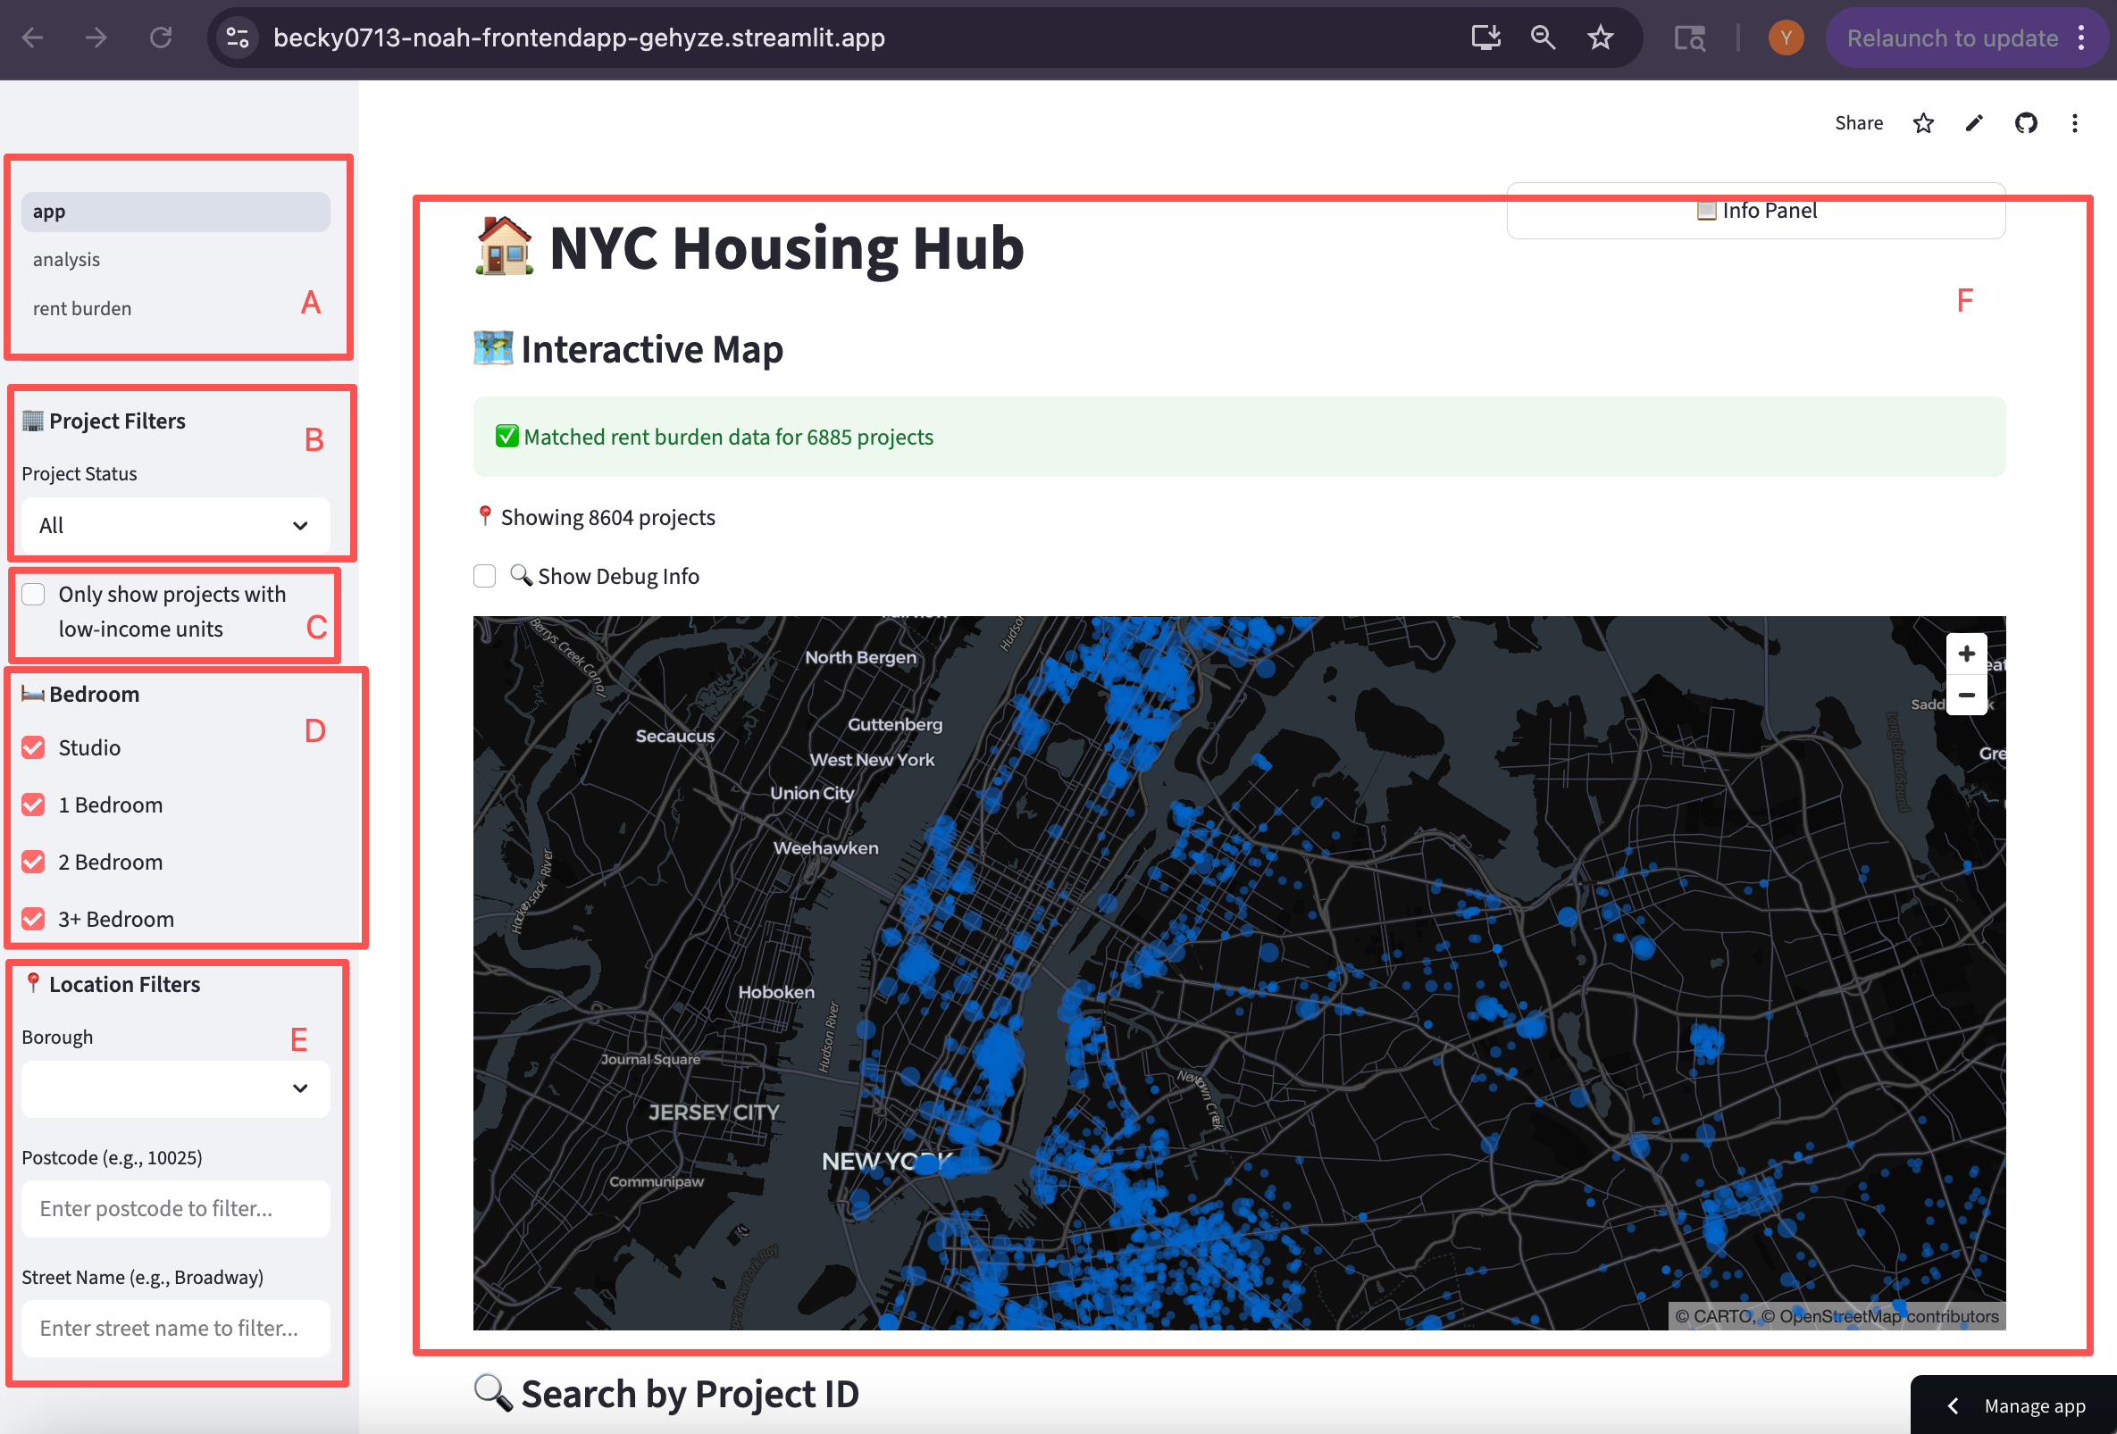

Figure ‑ Introduction of App Page

**A. Main Navigation Panel**

This is the primary navigation panel of the website. It contains three tabs, with **“app”** being the default landing page when the website opens.

**B. Project Filters – Project Status**

The first filter allows users to narrow results by **project status**.  
You can choose between **“In Progress”** or **“Completed”** projects.

**C. Low-Income Unit Filter**

This checkbox enables users to filter the map to show **only projects that include low-income units**.

**D. Bedroom-Type Filter**

Users can filter projects based on the **types of units available** (e.g., Studio, 1 Bedroom, 2 Bedroom, 3+ Bedroom).  
This is particularly useful for users who want to see where larger family-sized units (such as 3+ bedrooms) are available.

**E. Location Filters**

This section allows users to filter by **borough, ZIP code, or street name**, helping renters or researchers quickly focus on a specific neighborhood or area within NYC.

**F. Interactive Map**

The main interactive map visualizes all affordable housing projects.  
When hovering over any point (each dot represents an individual affordable housing project), a detailed info panel appears showing additional attributes of that project.  
(See the next screenshot for the hover details.)

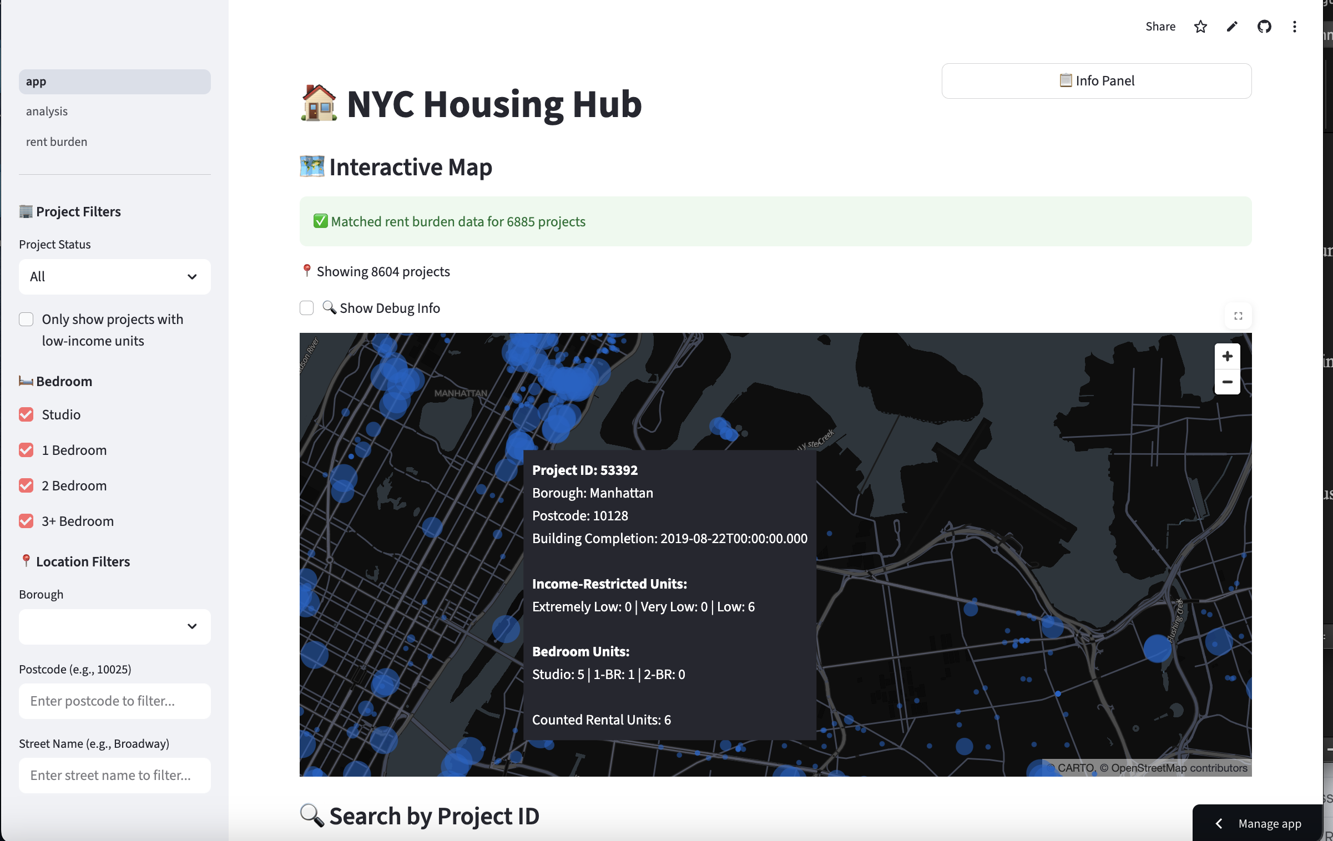

Figure ‑ Interactive Map

As shown in the figure, when the cursor hovers over a dot on the map, a tooltip appears displaying the following information:

* **Project ID**
* **Borough**
* **Postcode**
* **Building completion date**
* **Types and counts of income-restricted units**
* **Types and counts of bedroom units**
* **Total number of rental units**

These details cover most of the essential information about each project.  
If users wish to view **more comprehensive information**, they can scroll down to the **“Search by Project ID”** section and enter the desired project ID to retrieve the full project profile.

For example, if we search for the project with ID **53392**, the dashboard will display the following information, as shown in the next screenshot:

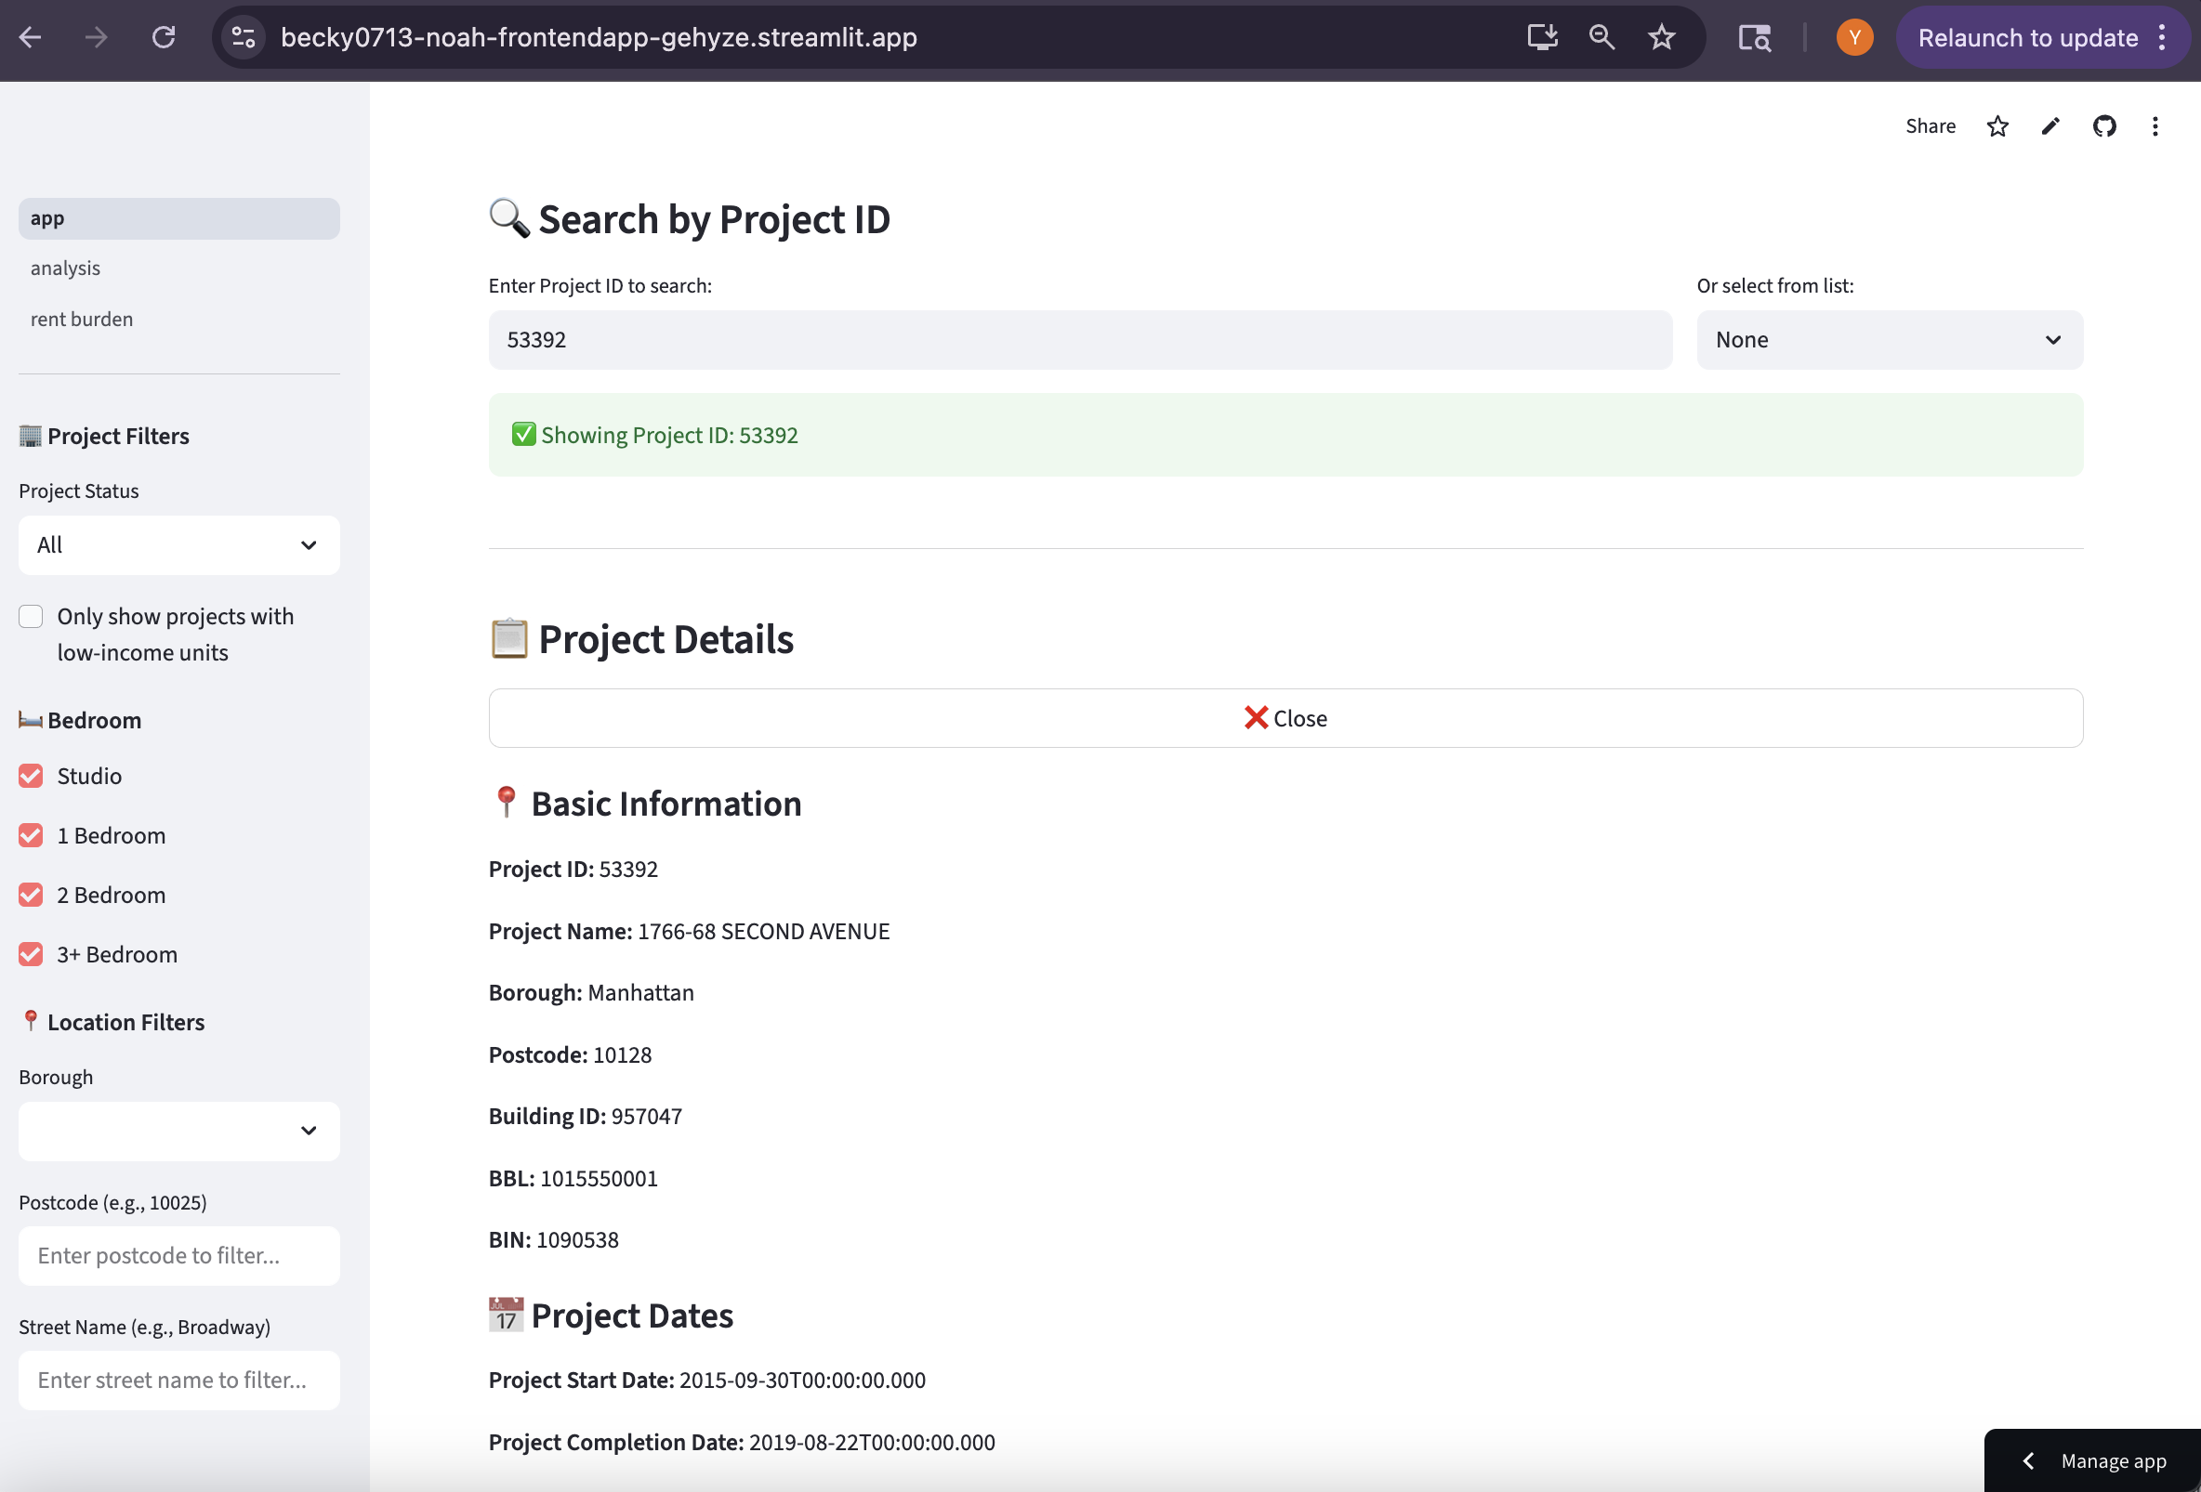

Figure ‑ Result 1 of “Search by Project ID”

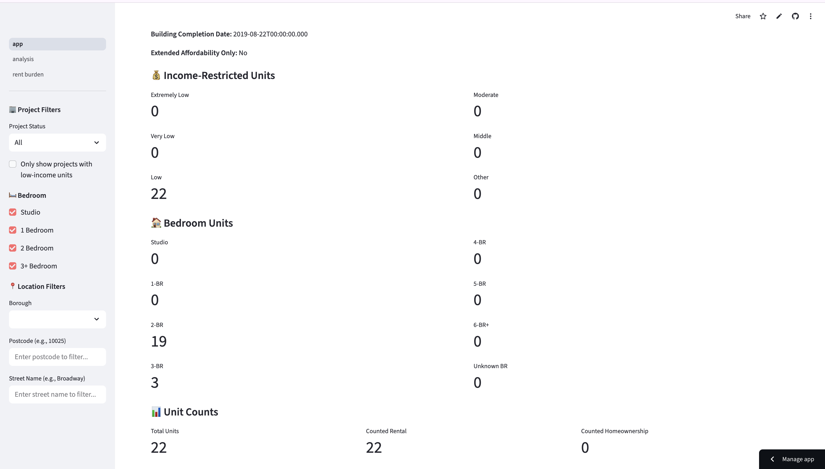

Figure ‑ Result 2 of “Search by Project ID”

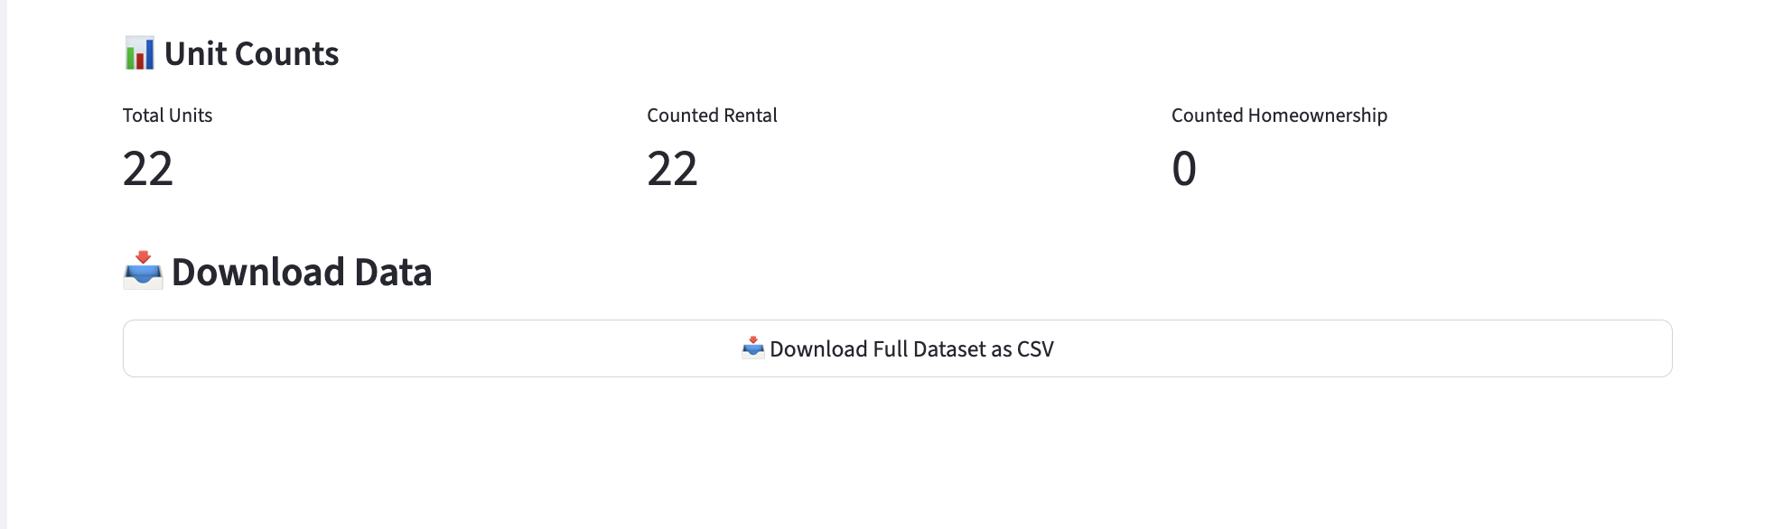

Figure ‑ Data Download Function

Regardless of whether a user performs a project-specific search, all data related to affordable housing displayed on this page can be downloaded directly using the **“Download”** section. This allows users to export the full dataset for further analysis or offline use.

### 6.2.2 Page 2 - Analysis Page

A. Value Lookup

Users can select a **Bedroom Type**, enter a **ZIP code**, and choose the **indicator** they want to view, including three options -- median income, median rent, or rent burden.

Note that the **Bedroom Type** filter applies **only to median rent**, since rental prices vary by unit type. For median income and rent burden, users do not need to select a bedroom type to perform the lookup.

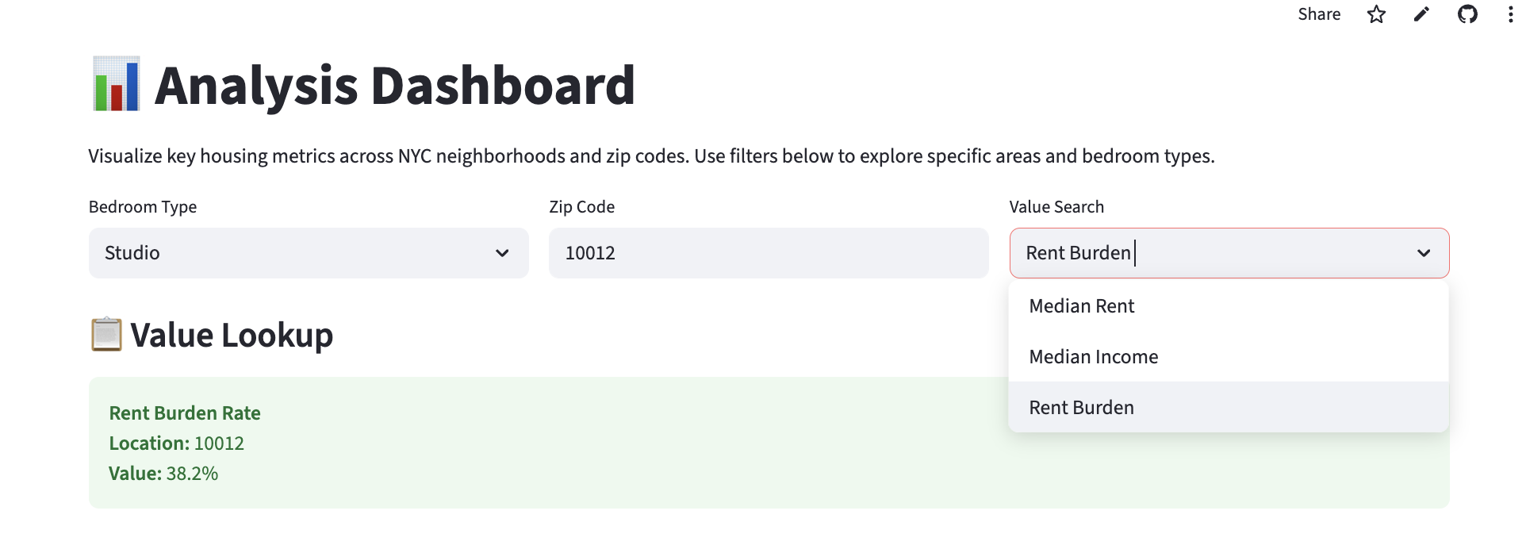

Figure ‑ Analysis Dashboard, Value lookup

### B. ****Most Critical Areas****

Users can specify their criteria through a set of dropdown menus:

* **Metric Type** (e.g., Lowest Median Income or Highest Rent Burden)
* **Borough** (or All NYC)
* **Number of Results** — this determines how many of the most critical ZIP codes the user wants to view

After running the search, the module returns a list of ZIP codes that meet the selected criteria, along with their corresponding indicator values.

As shown in figure 6-8, users may also choose to display only the **top three** results.  
Additionally, when hovering over the **three dots** in the upper-left corner of the table, several options appear. These include:

* **Filter** (apply additional conditions)
* **Download** (export the table data)
* **Search** (locate specific entries within the table)
* **Enlarge** (expand the table for better visibility)

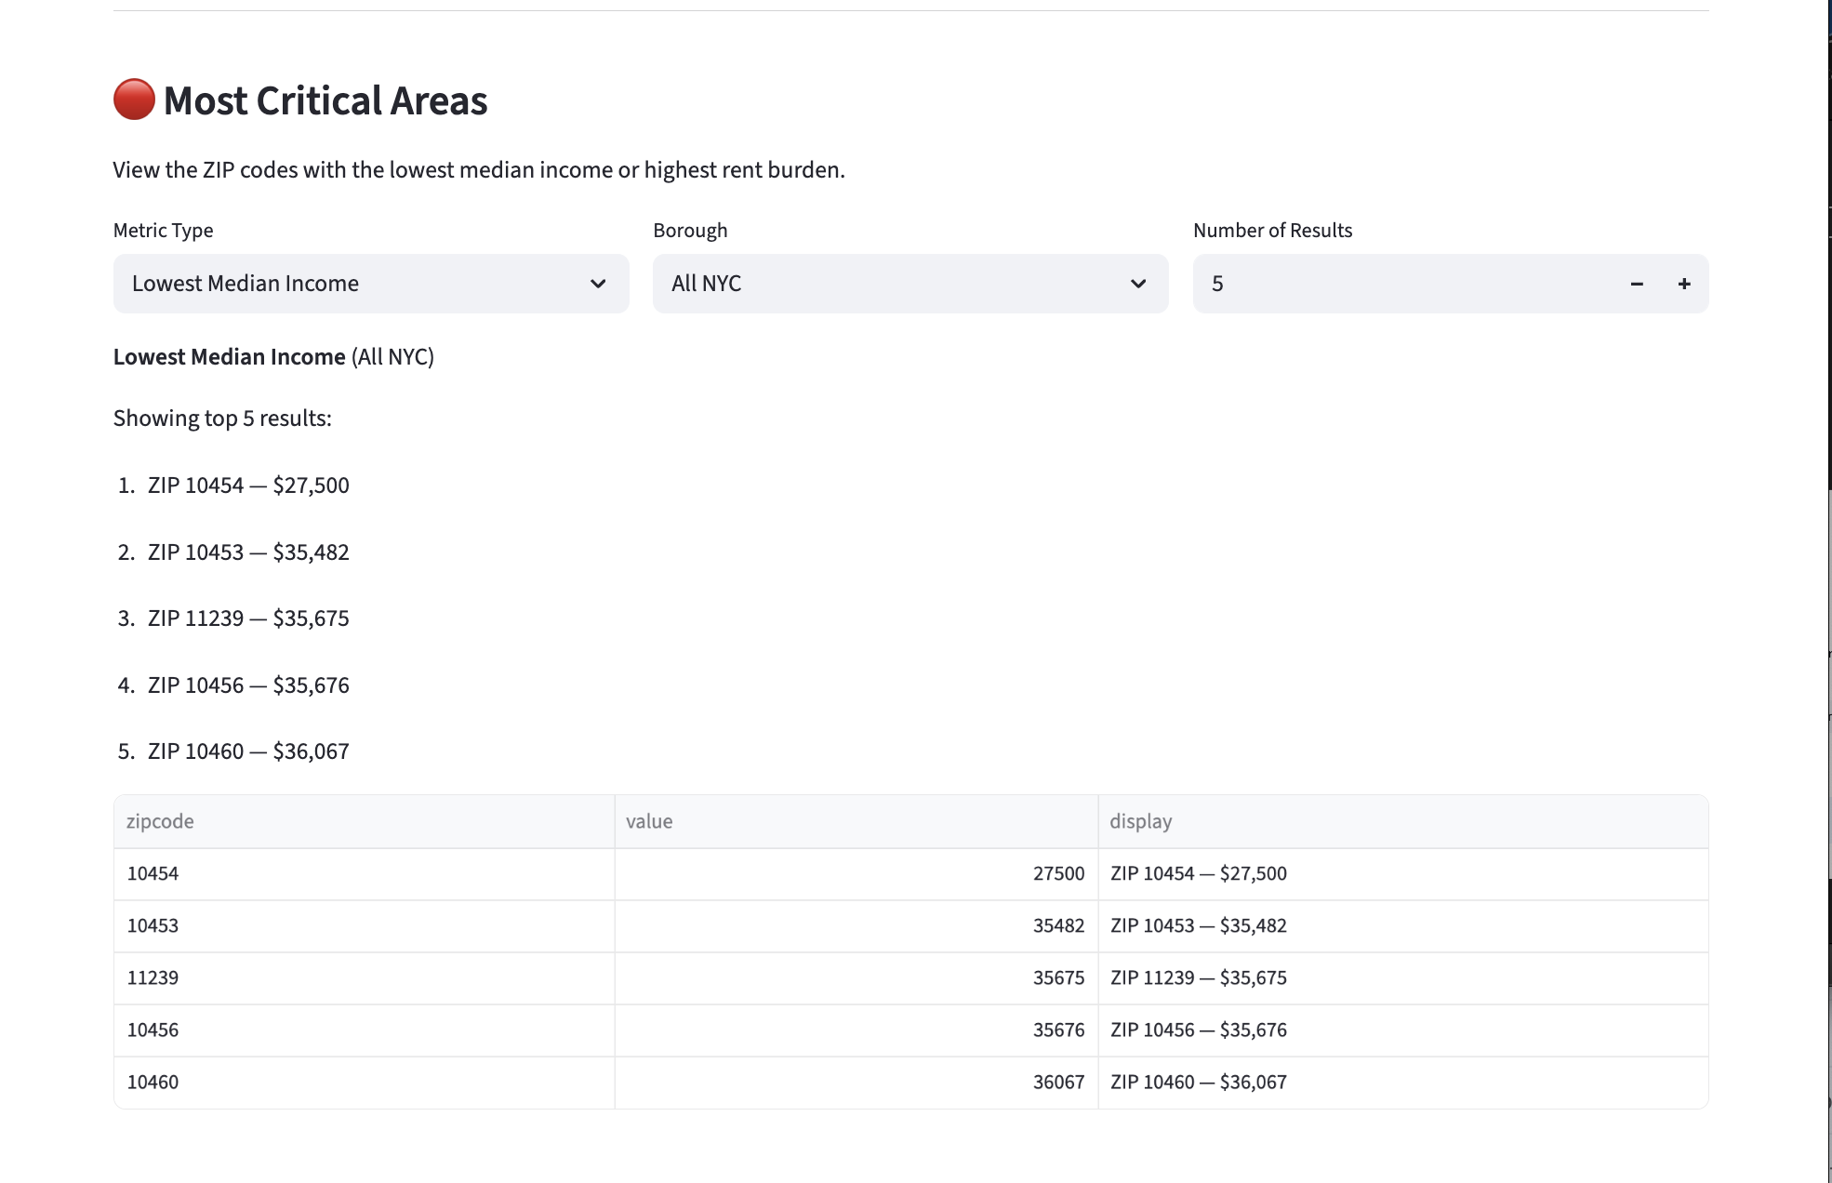

Figure ‑ Analysis Dashboard, Most Critical Areas, Outlook

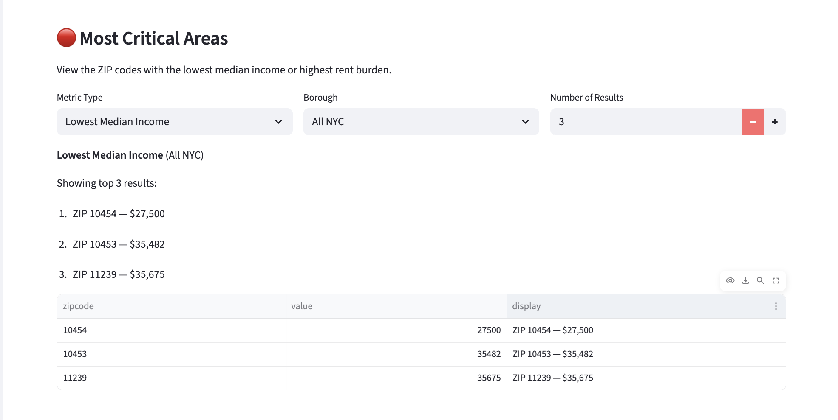

Figure ‑ Analysis Dashboard, Most Critical Areas, Table Operation

### C. ****Visualization Maps****

Users can choose to view any of the following map layers:

* **Median Rent**
* **Median Income**
* **Rent Burden**

Each map provides an interactive, ZIP-code–level visualization to help users quickly identify geographic patterns and affordability conditions across New York City.

**Map 1: Median Rent Map**  
Because rent levels vary significantly by **bedroom type**, the selection made in **Module 1** (Value Lookup) directly determines how this map is displayed. A bedroom type **must** be selected for the median rent map to load properly.

In the example shown, the selected unit type is **Studio**. The map displays **54 ZIP codes** that contain studio rental data. On the color scale, **red indicates higher median rent**, while **green indicates lower rent** levels. When the user hovers over any ZIP code on the map, a tooltip appears showing the **exact median rent value** and the **corresponding area name**.

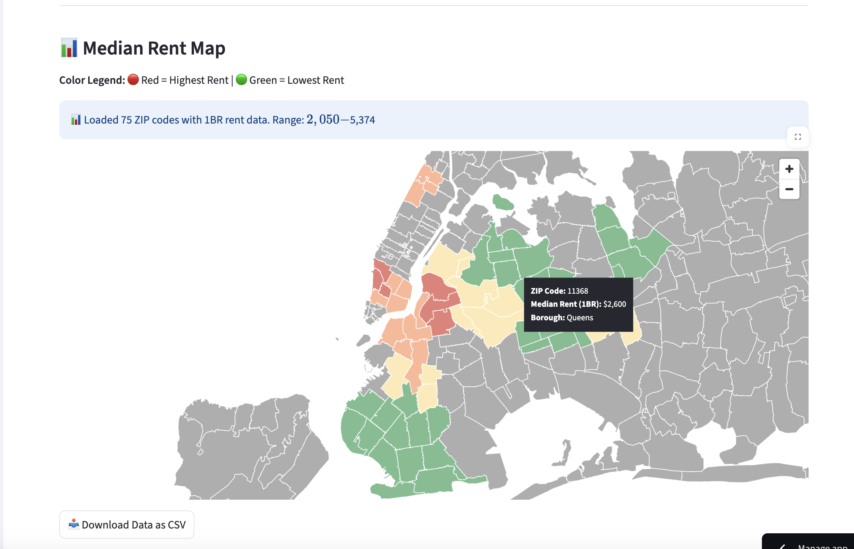

Figure ‑ Median Rent Map

**Map 2: Median Income Map**  
Unlike the median rent map, the **median income map** is **not affected** by the bedroom type selection and will display normally regardless of the chosen unit type. In this visualization, **red represents lower median income**, while **green represents higher income** levels across ZIP codes. When the user hovers over a specific ZIP code on the map, a tooltip appears showing the **exact median income value** and the **corresponding area name**.

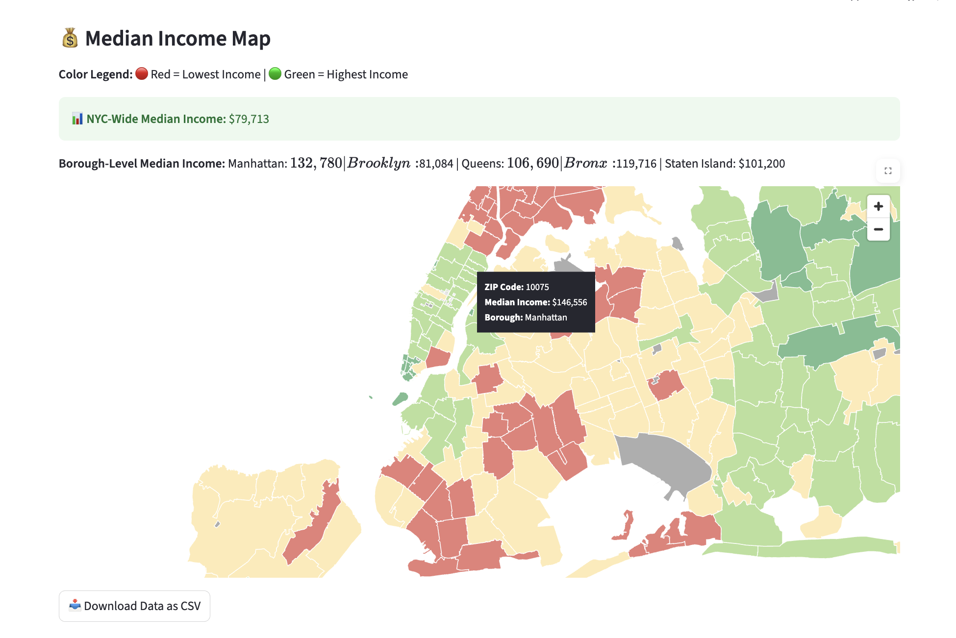

Figure ‑ Median Income Map

**Map 3: Rent Burden Map**  
Similar to the median income map, the **rent burden map** is **not affected** by the bedroom type selection and will display normally regardless of the chosen unit type. ZIP codes where **30%–50% of households** are rent-burdened appear in **yellow**, while areas where **more than 50%** of households are rent-burdened appear in **red**. The color intensity increases as the rent burden percentage rises. When the user hovers over a ZIP code, a tooltip displays the **exact rent burden value** and the **corresponding area name**.

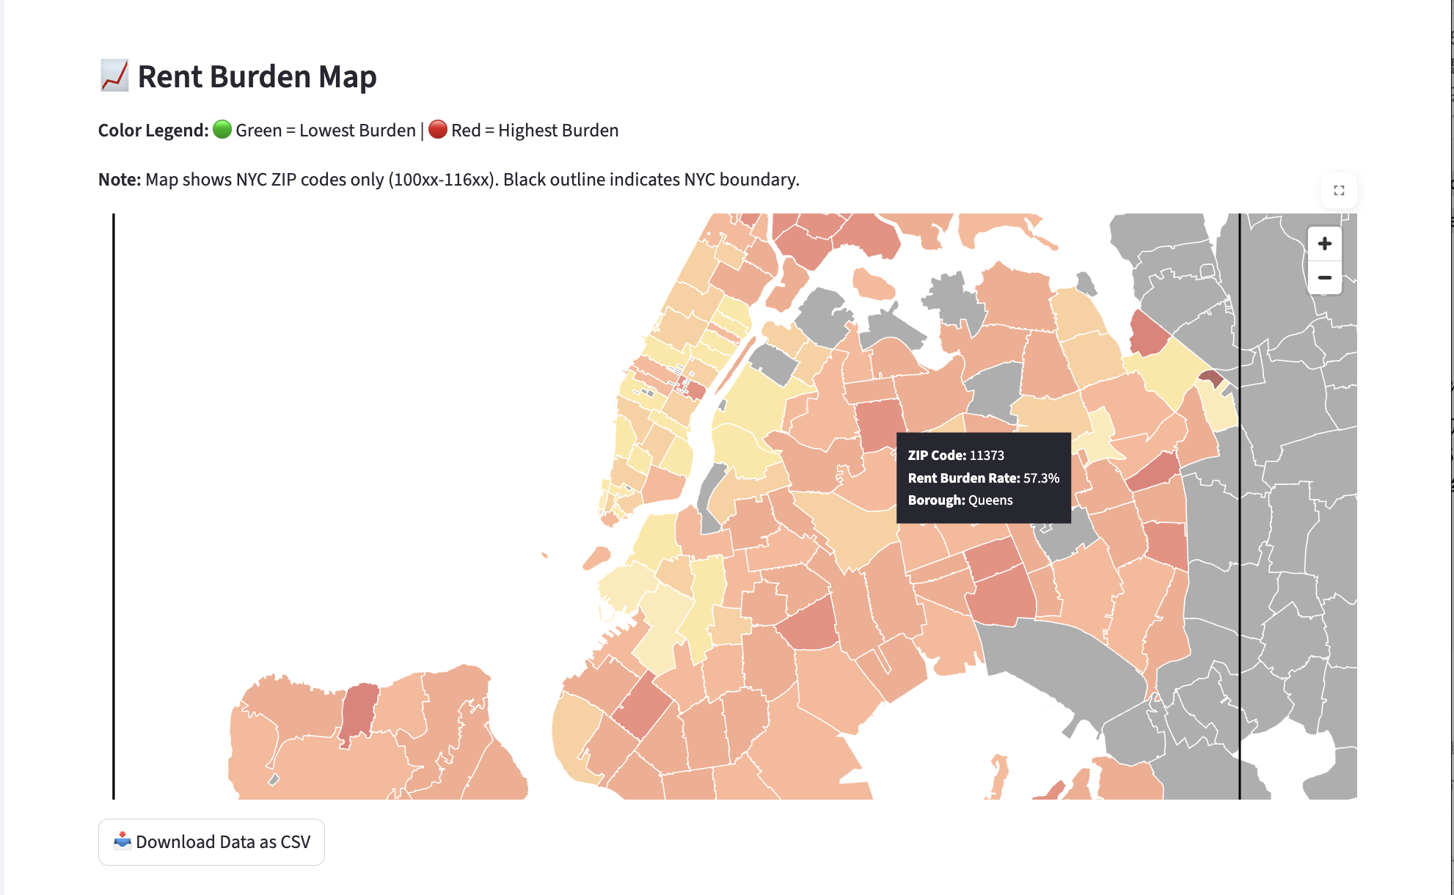

Figure ‑Rent Burden Map

### 6.2.3 Page 3 - Rent Burden page

The **third module** on the Rent Burden page provides a **macroscopic analysis** of rent burden patterns across New York City.

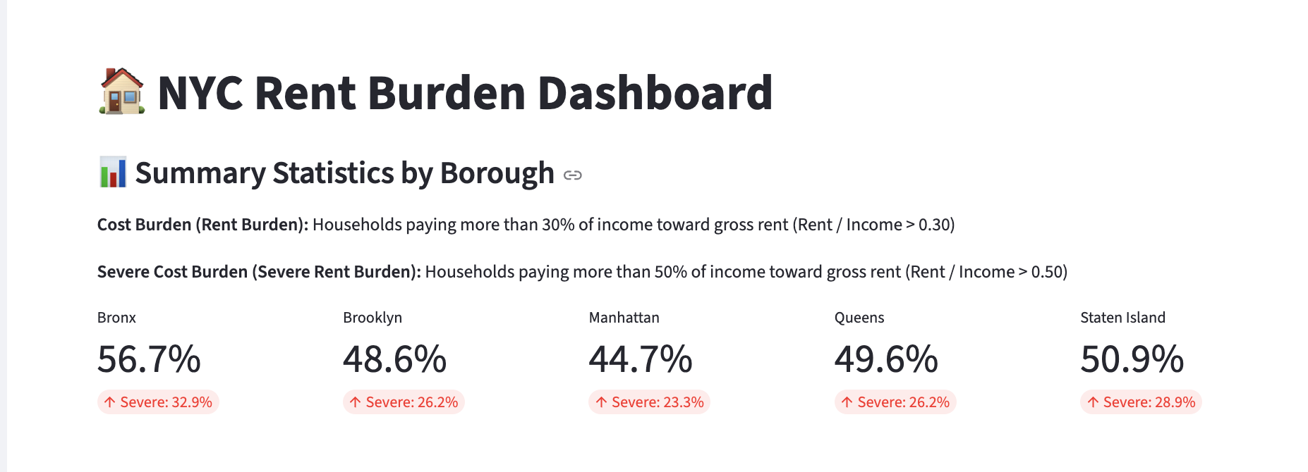

Figure ‑ Rent Burden Dashboard, Summary Statistics

* 1. **Borough-Level Rent Burden Data Summary**  
     Figure 6-12 displays the **average rent burden rate for each borough**, accompanied by a numerical summary of the **rent burden thresholds** (e.g., >30%, >50%). These values help users understand the differences in affordability challenges across boroughs. The underlying borough-level dataset can also be downloaded directly by users.

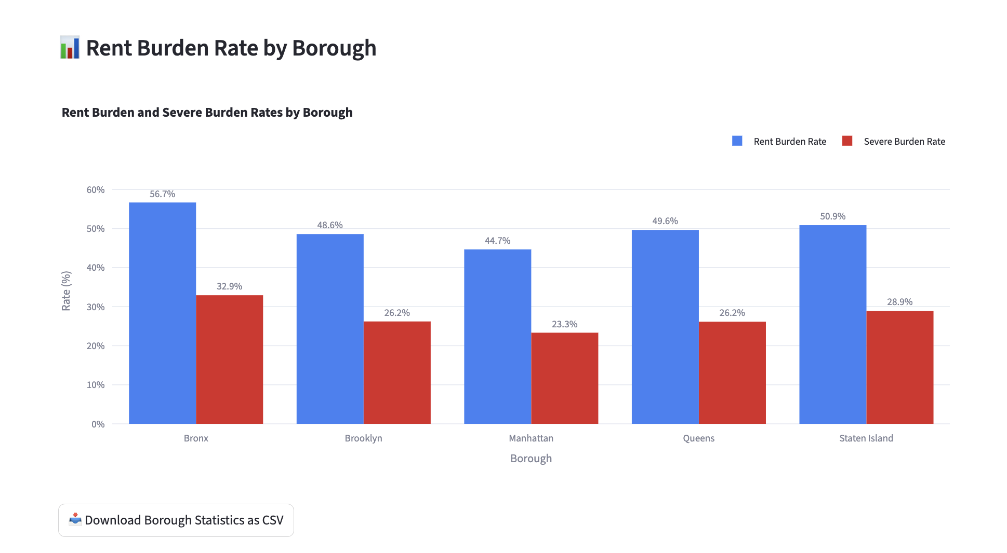

Figure ‑ Rent Burden Dashboard, **Rent Burden Histogram**

* 1. **Rent Burden Histogram**  
     The second chart presents these rent burden values in the form of a **histogram**, providing a more intuitive view of the overall distribution. This allows users to see how rent burden is spread across ZIP codes and where the most common burden levels fall.

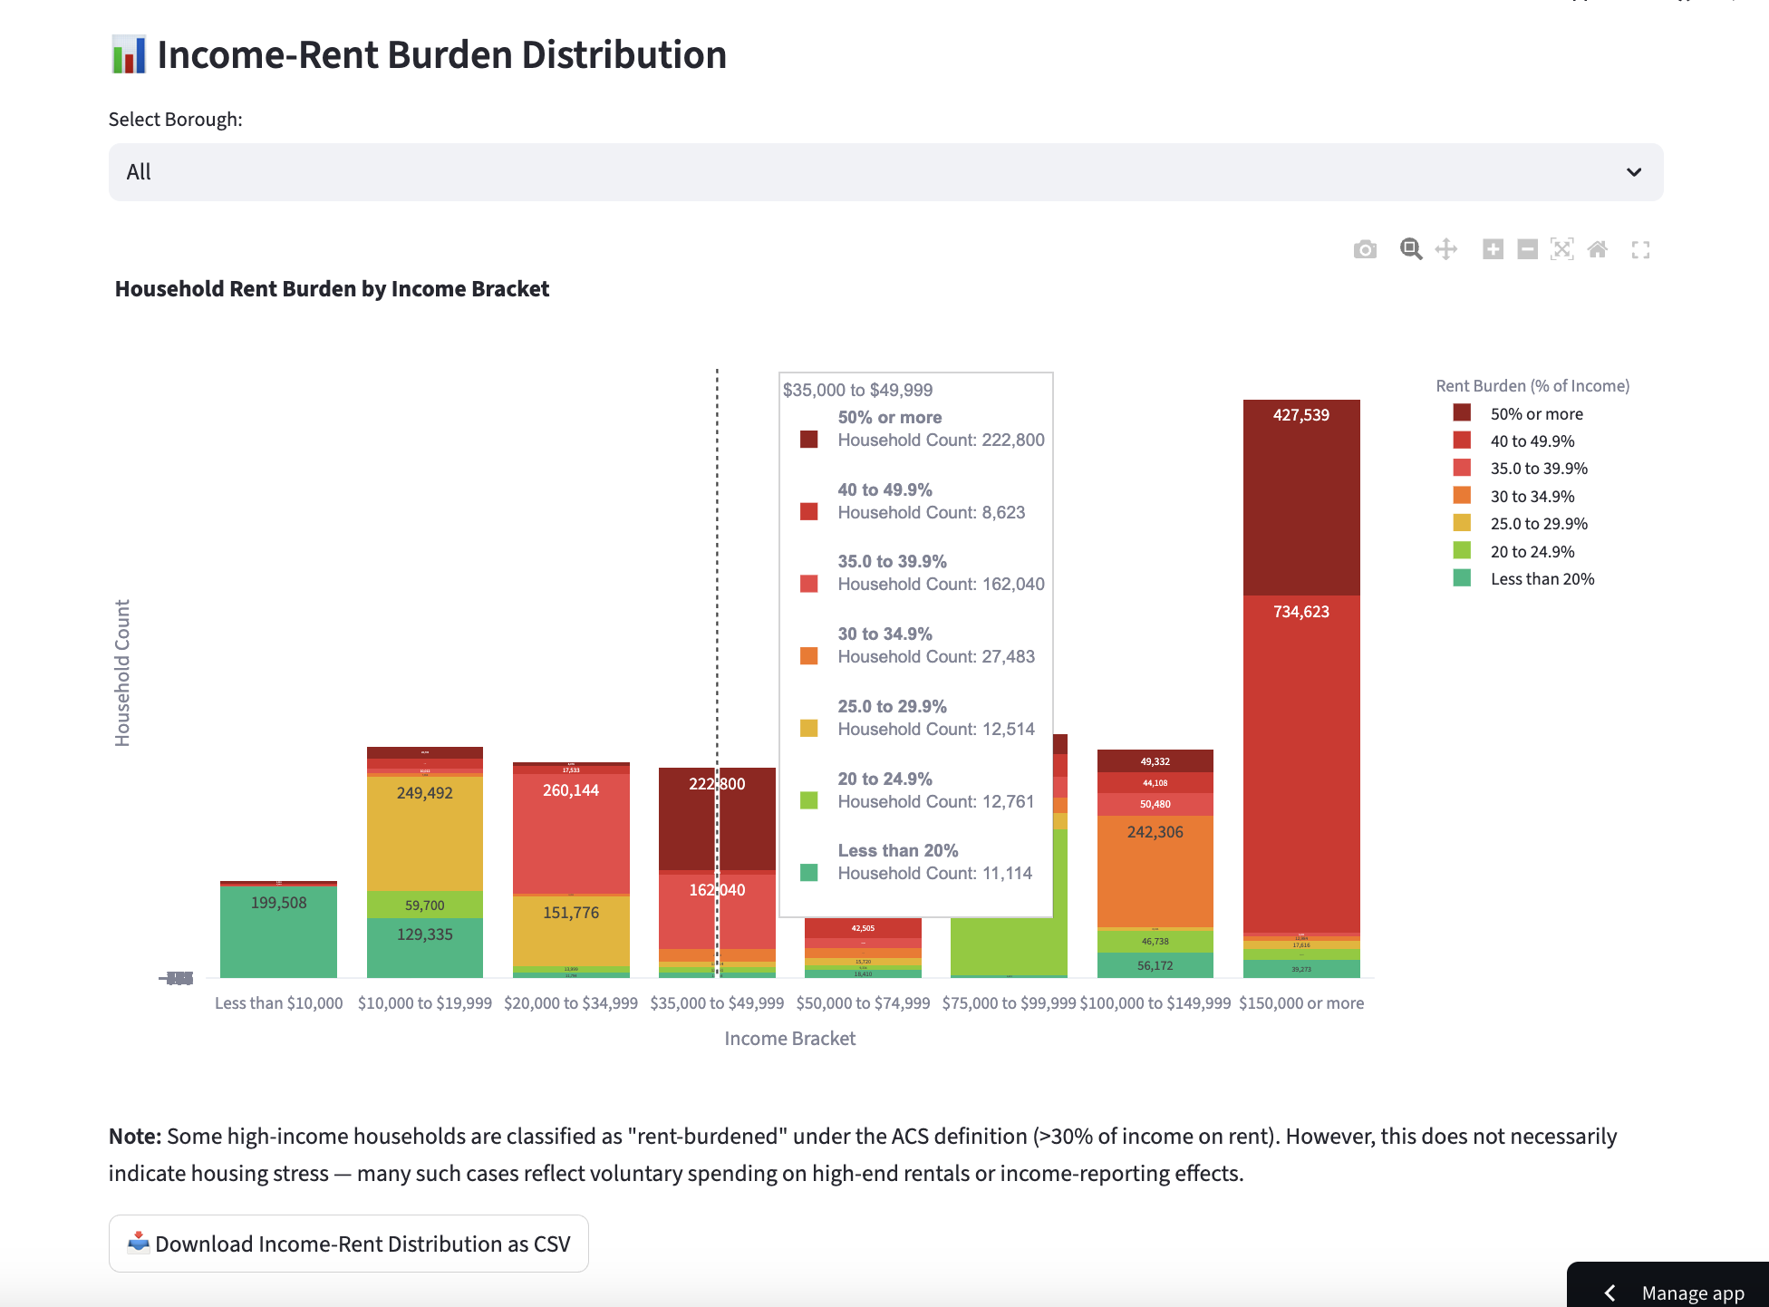

Figure ‑ Income Rent Burden Distribution, All Borough

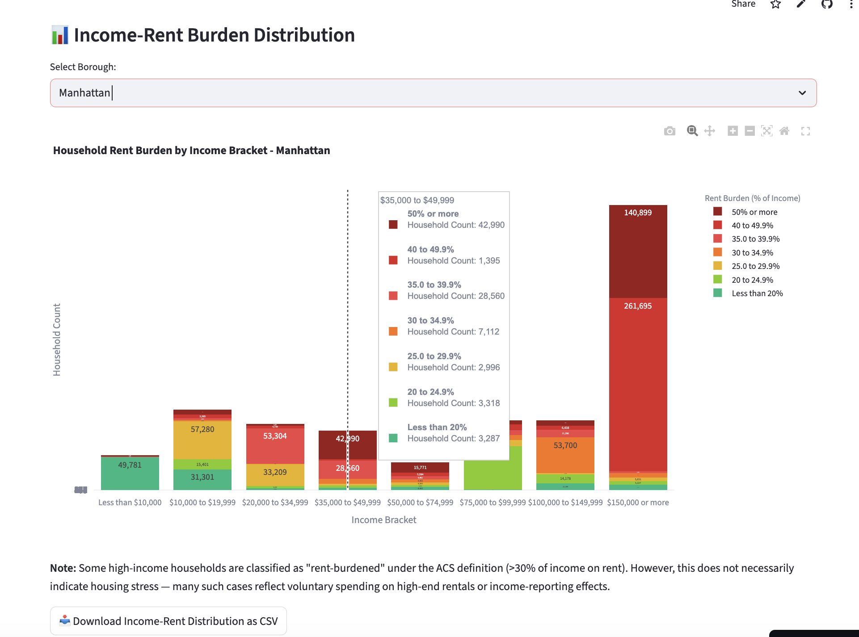

Figure ‑ Income Rent Burden Distribution, Manhattan

* 1. **Income–Rent Burden Distribution**  
     Figures 6-15 (the whole New York city) and 6-16 (Manhattan Borough) display the **distribution of rent burden across different income ranges**. Users can filter the chart by borough to focus on specific areas. Rent burden levels are represented as a **stacked bar chart** with distinct colors corresponding to different burden percentages, making it easier to compare affordability across income groups.

## 6.3 Findings

The integrated datasets revealed several notable spatial and socioeconomic patterns across New York City.

**A. NYC Rent Burden is High Almost Everywhere**

Analysis shows that **nearly all ZIP codes in NYC exceed the 30% rent burden threshold**, meaning that most NYC households are rent-burdened by federal standards. This indicates citywide affordability pressure, not isolated to a few low-income areas.

**B. Higher-Income ZIP Codes Appear to Have Higher Rent Burden—Why?**

Some affluent ZIP codes surprisingly show **rent burden rates comparable to or higher than low-income areas**.  
This may occur because:

* High-income ZIPs also have **extremely high rents**, raising the proportion of households spending >30% on rent even if incomes are high.
* Wealthier neighborhoods often have **large renter populations of young professionals**, whose high rent-to-income ratios reflect lifestyle decisions rather than poverty.
* The ACS rent burden metric is based on **all renter households**, not only long-term residents. Newcomers often pay premium rents.

Thus, “high burden” in wealthy areas reflects **market competitiveness and spending choices**, not financial hardship.

**C. Rent Prices Exhibit Strong Geographic Divides**

* **Manhattan (except some pockets of Upper Manhattan) and certain parts of Brooklyn** show the highest median rents, especially in ZIP codes such as 10014, 10011, 11201, and 11215.
* **The Bronx and most of Queens** show substantially lower rents across all bedroom types.  
  This reflects both income disparities and historical development patterns.

**D. Affordable Housing Supply is Uneven**

Using the project-level supply map:

* **Midtown Manhattan has very few affordable housing projects**, compared to Upper Manhattan and Lower Manhattan.
* Brooklyn displays a mixed pattern, with concentrations of affordable units in Central Brooklyn but limited supply in high-cost coastal areas.
* The Bronx has the largest number of affordable housing projects relative to land area.

**E. Rent-to-Income (Rent Burden) Ratios Reflect Combined Market Pressure**

Even in areas with moderate rents, low incomes create affordability strain.  
Similarly, high-income neighborhoods still show ratios above 0.30 due to extremely high asking rents.

**F. Income and Rent Maps Align but Also Reveal Outliers**

In some ZIP codes:

* **High income + high rent = “expected” equilibrium**
* **Low income + low rent = “expected” equilibrium**
* **High income + high burden OR low income + moderate rent = “unexpected outliers”**  
  These outliers represent neighborhoods where additional policy focus may be needed.

## 6.4 Summary Statistics

High-level summary statistics derived from the final processed datasets include:

| **Indicator** | **Range** | **Interpretation** |
| --- | --- | --- |
| Median Rent (Studio) | $2,050 – $6,200 | Strong spatial variation; Manhattan highest |
| Median Household Income | $2500 – $250,000+ | Wide socioeconomic disparities |
| Rent Burden (>30%) | 6% – 86% | Burden highest in lower-income areas |

To complement the dashboard visualizations, the processed datasets reveal several notable patterns across New York City’s ZIP codes. Studio median rents show substantial geographic dispersion, ranging from approximately $2,050 in lower-cost neighborhoods to more than $6,200 in high-demand Manhattan areas, illustrating the sharp spatial gradient of rental market pressures. Median household income exhibits an even wider spread, from roughly $25,000 in lower-income communities to more than $250,000 in affluent areas, reflecting persistent socioeconomic inequality across the city’s neighborhoods. Rent burden also varies significantly, with the share of households paying more than 30 percent of income on rent ranging from 6 percent in higher-income ZIP codes to more than 80 percent in some of the lowest-income areas. These statistics indicate that affordability challenges are not limited to any single borough or demographic group but instead reflect a complex interaction between market rent levels, local economic conditions, and household income distribution. Together, these patterns reinforce the need for consistent, spatially harmonized indicators to support comparative analysis and policy evaluation across the city.

## 6.5 Implications

### ****6.5.1 Practical Implications****

For policymakers, researchers, and housing agencies, the dashboard provides a more efficient way to monitor affordability and prioritize interventions.  
It enables:

* Rapid identification of high-burden neighborhoods
* Clear comparisons between market conditions across boroughs
* Insight into whether affordable housing supply corresponds to areas with the greatest financial strain
* A repeatable, automated workflow that reduces reliance on manual data collection

These practical improvements can support planning decisions, resource allocation, and ongoing program evaluation.

### ****6.5.2 Theoretical Implications****

The project also demonstrates the value of harmonizing datasets published at different geographic resolutions.  
By transforming tract-level variables to ZIP-level indicators through weighted crosswalks, the system shows how consistent spatial units enhance interpretability and analytical coherence.  
This approach provides a methodological foundation for future urban informatics projects that require integrating multi-source data into a single analytical framework.

## 6.6 Summary

In summary, the project successfully developed an integrated data pipeline and interactive dashboard that unifies income, rent, rent burden, and affordable housing data across all ZIP codes in New York City. By implementing automated ETL processes, standardized database structures, and geospatial visualization tools, the system offers a clearer and more accessible framework for analyzing housing affordability. The resulting unified spatial dataset enables consistent cross-neighborhood comparisons and reveals distinct affordability patterns, including pronounced rent burdens in lower-income communities and substantial geographic variation in both market rents and household incomes. The analysis also highlights observable mismatches between the locations with the greatest affordability pressures and the distribution of affordable housing supply. Furthermore, automation contributed to a marked reduction in data processing time, improving data freshness and reliability. Taken together, these outcomes provide a comprehensive and analytically coherent view of housing affordability conditions in New York City, strengthening the foundation for both empirical research and policy-oriented decision-making.

## 6.7 Repository of Data Sets and Code

All datasets and the full codebase for the ETL pipeline, FastAPI backend, and Streamlit dashboard are available at: <https://github.com/Becky0713/NOAH>

This repository constitutes the complete technical record of the NYC Affordable Housing Dashboard and contains all materials necessary to reproduce the ETL pipeline, backend services, database schema, frontend interface, and deployment environment.

The repository’s root directory includes the core FastAPI backend implementation and the data-processing scripts responsible for harmonizing and transforming the various housing datasets used in the project. These scripts perform tasks such as variable standardization, type cleaning, ZIP-code crosswalk operations, rent burden calculations, and the ingestion of processed tables into PostgreSQL/PostGIS. The backend code also defines the project’s REST API endpoints, which provide structured JSON and GeoJSON outputs to the dashboard interface.

A collection of technical documentation is included in the form of multiple Markdown files. These documents describe the required PostgreSQL/PostGIS configuration (DATABASE_SETUP.md), the structure and loading procedure for the project’s database schema (DATABASE_INTEGRATION_GUIDE.md), and the workflow for connecting DBeaver and other interfaces to the cloud-hosted database (DBEAVER_TO_STREAMLIT.md). Additional documents, including the deployment guides (DEPLOYMENT.md, QUICK_DEPLOY.md, and FREE_DEPLOYMENT.md), specify the steps needed to deploy the system on Render, Fly.io, or alternative cloud platforms. These guides are accompanied by the relevant configuration files, such as Dockerfile, docker-compose.yml, Procfile, fly.toml, and render.yaml, which together define the containerized environment used for backend deployment.

The frontend Streamlit dashboard is contained within a dedicated folder in the repository and includes the full application code used to generate the project’s interactive maps, affordability indicators, ZIP-level lookups, and filter-based exploration tools. Configuration files stored in the .streamlit directory specify the runtime environment and theme settings for the deployed dashboard. The interface draws directly from the FastAPI backend and the cloud-hosted PostgreSQL database through secure connections documented in the repository’s integration notes.

Finally, the repository contains a set of auxiliary materials that supported development, including migration notes, rent burden documentation, free-database options, and project progress logs. Together, the codebase and documentation form a fully reproducible environment that enables future researchers, policy analysts, and practitioners to extend, audit, or redeploy the dashboard. The repository therefore serves not only as an archive of the project’s technical work but also as a reference implementation for building integrated housing data systems leveraging modern spatial database and cloud technologies.

# ****Issues Encountered****

During the development of the NOAH Affordable Housing Dashboard, several issues emerged across data acquisition, ETL implementation, database design, and deployment. While none of these issues threatened the overall project timeline, each required timely resolution to maintain data quality, system stability, and analytical consistency. This section summarizes the main issues encountered and describes how they were addressed, as well as how they relate to the risk management plan.

## ****7.1 Data Quality and Inconsistent Formats****

One of the earliest challenges involved inconsistencies across datasets obtained from ACS, StreetEasy, PLUTO, and various NYC Open Data portals. The formatting of ZIP codes, tract identifiers, and GEOIDs varied widely across files. Some datasets used strings, others used integers; some ZIP codes dropped leading zeros; and some fields included hyphens or irregular spacing.

These inconsistencies caused upload failures in PostgreSQL, table schema mismatches, and difficulty joining tables during ETL. Some datasets contained non–New York City entries, blank values, or incomplete fields.

**How the issue was handled:**

* Implemented uniform typing and formatting rules in the ETL scripts (e.g., converting ZIP codes to five-digit strings).
* Added steps to remove hyphens, spaces, and invalid identifiers.
* Dropped non-NYC observations and rows with unrecoverable missing values.
* Standardized column naming across all datasets before uploading to the cloud database.
* Built SQL-level constraints (e.g., primary keys, NOT NULL rules) to prevent accidental ingestion of malformed data.

This issue was anticipated in the risk management plan under **“Data Integrity Risk”**, and the mitigation strategy—consistent data validation and quality checks—successfully prevented downstream errors.

## ****7.2 Geographic Misalignment Between Tract-Level and ZIP-Level Data****

A major structural challenge was that ACS indicators (rent burden, income, demographics) are published at the census-tract level, while StreetEasy rental data exists at the ZIP-code level. Directly merging these datasets is impossible without geographic harmonization.

Initially, attempts to merge ACS tracts with ZIP data resulted in duplicate rows, incorrect aggregations, or mismatched geometry coverage.

**How the issue was handled:**

* Integrated an external tract-to-ZIP crosswalk with population-based allocation factors.
* Added weighted calculations to allocate tract values proportionally to ZIPs.
* Validated ZIP-level results by comparing row counts and geographic coverage with USPS ZIP boundaries.

This issue was included in the risk plan as **“Geographic Resolution Mismatch”**, and the planned mitigation—using a validated crosswalk—resolved the misalignment effectively.

## ****7.3 SQL Table Creation Errors and Cloud Database Upload Failures****

Throughout development, multiple issues occurred during PostgreSQL table creation and cloud database uploads:

* Columns with the same name but different data types
* Attempts to add columns that already existed
* Geometry fields failing to upload due to invalid shapes
* Insertions failing because of batch-insert errors in DBeaver

These issues blocked ETL progress and temporarily prevented the dashboard from showing updated values.

**How the issue was handled:**

* Dropped and recreated problematic tables using clean schemas.
* Introduced explicit data-type casting in Python (e.g., ensuring numeric fields were uploaded as floats instead of text).
* Added PostGIS functions (ST_MakeValid) to fix invalid geometries.
* Disabled batch insert in DBeaver when necessary.
* Established a naming convention for all database tables to keep the schema clean and predictable.

This was partially predicted in the risk plan as **“Database Schema Risk”**, and the contingency—allowing for iterative rebuilds and backup scripts—was used to resolve the issues.

## ****7.4 Spatial Rendering Issues in PyDeck****

During visualization, ZIP-code shapes sometimes failed to render or appeared distorted due to invalid polygons or missing geometry rows in the database. Additionally, non-NYC ZIPs were initially included, making the map cluttered and misleading.

**How the issue was handled:**

* Filtered geometry tables to include only NYC ZIP codes.
* Repaired geometry using PostGIS and validated polygon integrity.
* Re-exported the corrected geojson for use in PyDeck.

This issue was not explicitly listed in the original risk plan but relates to the broader category of **“Visualization Risk”**. The resolution improved map clarity and ensured that users see only NYC-relevant shapes.

## ****7.5 API Connectivity and Deployment Limitations****

When deploying the backend on Render, intermittent API timeouts and schema mismatches occurred. The frontend occasionally attempted to access endpoints before the backend finished initializing, resulting in 404 errors or incomplete data loads.

**How the issue was handled:**

* Added health-check routes and delayed frontend map loading until API responses were confirmed.
* Updated API documentation and tightened Pydantic schema validation.
* Applied retry logic for selected queries to improve stability.

This issue aligns with the risk plan category **“Deployment and Hosting Risk”**, and the mitigation strategies—API validation and retry logic—helped maintain uptime.

## ****7.6 Project Scope Adjustment****

Initially, the dashboard included a planned “Access & Complaint Data” module (311 complaints, CouncilStat). However, due to time constraints and inconsistent formatting of these datasets, the module was removed from the final scope.

**How the issue was handled:**

* The scope was narrowed to the four highest-value modules: income, rent, rent burden, and affordable housing supply.
* The database structure was simplified accordingly, reducing complexity and ensuring a complete, high-quality final deliverable.

This falls under **“Scope Risk”** in the risk plan, and adjusting the scope early prevented delays.

## 7.7 Risk management plan

At the outset of the project, several categories of risks were anticipated, including potential changes to public APIs, inconsistencies across NYC open datasets, spatial resolution mismatches, cloud deployment failures, and time limitations. To address these risks, contingency strategies were prepared in advance, such as maintaining backup data exports, implementing schema validation prior to database upload, establishing a staging environment for deployment testing, and prioritizing core features when time constraints became binding.

During implementation, the most significant issue encountered was data inconsistency across multiple public sources. These discrepancies included missing values, invalid GEOIDs, and ZIP-code formats that conflicted across datasets. This issue had been anticipated, and the planned mitigation—schema standardization and field-level validation—was applied immediately, ensuring reliable ingestion and preventing downstream errors in the database and dashboard.

A second issue arose from the geographic mismatch between tract-level ACS variables and ZIP-level market rent data. The predefined contingency strategy—using a population-weighted tract-to-ZIP crosswalk—was implemented to harmonize the datasets. This allowed indicators from different spatial units to be aggregated consistently and enabled ZIP-level visualizations.

Deployment also presented challenges, including table-creation conflicts, geometry-field errors, and temporary failures in cloud hosting. These problems were resolved by reverting to a staging environment, rebuilding tables with clean schemas, and enforcing strict data-type consistency. This approach minimized downtime and protected the integrity of the development workflow.

Finally, the limited project timeline required deprioritizing non-essential modules, such as the Access & Complaint data component. Following the predefined time-management contingency, core analytics—rent burden, market rent, income, and spatial visualization—were completed first, ensuring the delivery of a fully functioning dashboard within the available hours.

Overall, the issues encountered aligned with the risks anticipated at project initiation, and the prepared mitigation strategies proved effective. These measures ensured stable progress, maintained data integrity, and enabled successful completion of the NOAH Affordable Housing Dashboard.

# Lessons Learned

Throughout the development of the NOAH Affordable Housing Dashboard, I gained a number of technical, analytical, and project management skills that significantly expanded my capability as both a data analyst and a systems developer. Although the project was successfully completed on time and achieved the expected level of quality, the learning experience proved even more valuable than the deliverable itself.

One of the most important lessons I gained was a deeper understanding of **end-to-end data engineering workflows**. Prior to this project, I had experience with data cleaning and analysis, but building an integrated pipeline—from raw public data APIs, to ETL processing in Python, to a structured PostgreSQL/PostGIS cloud database—required me to approach data from a more architectural perspective. I learned how to design database schemas, handle geo-spatial data, normalize inconsistent formats, manage crosswalk transformations, and maintain data quality across multiple sources. These are skills I had never applied at this scale before, and they fundamentally changed how I think about the reliability and reproducibility of analysis.

Another major area of growth was **full-stack system development**. I learned how to deploy a FastAPI backend, connect it to a cloud database, and design a Streamlit dashboard that could dynamically load geospatial layers. Prior to this project, I had never built a web-based tool that combined live API endpoints with interactive map visualizations. Debugging deployment issues, handling asynchronous data loads, and optimizing database performance taught me how different system components interact—and how easily one misalignment can break the entire workflow.

In addition, this project strengthened my **project and risk management abilities**. Throughout the 100-hour development timeline, I had to prioritize core functions, manage scope, and adjust expectations based on technical constraints. Several risks identified early—such as API instability, schema inconsistencies, and limited development time—did materialize during the project. Successfully resolving them using the planned contingency strategies showed me how valuable risk planning is, especially when working on a complex technical system with many dependencies.

Finally, I learned the importance of **clear communication and stakeholder alignment**. Regular updates with my sponsor helped ensure that the project’s direction remained aligned with real research needs at the Urban Lab. Their feedback also helped me refine features such as map clarity, dataset filtering, and the usability of the dashboard interface. This experience taught me how iterative feedback, version tracking, and expectation management contribute directly to project quality.

Overall, the project was an invaluable learning experience. It allowed me to bridge data engineering, geospatial analytics, backend development, and visualization into a single integrated system. More importantly, it strengthened my ability to plan, execute, and deliver a complex technical project from scratch—skills that I will carry forward into future professional and academic work.

# ****Conclusion and Further Work****

## ****9.1 Conclusions****

### ****9.1.1 Overall Outcomes****

The primary goal of this project was to create an integrated, automated, and user-friendly data platform that consolidates NYC affordable housing datasets into a single dashboard for spatial analysis and decision-making. This goal was fully achieved. The resulting system successfully aggregates data across income, rent, rent burden, and affordable housing supply, and presents them through interactive geospatial visualizations supported by a robust backend and spatial database.

### ****9.1.2 Key Findings****

The analysis revealed several notable patterns regarding housing affordability across New York City. First, rent burden levels remain persistently high across nearly all ZIP codes, suggesting that affordability pressures are not confined to specific neighborhoods but instead represent a citywide structural challenge. Spatial patterns in rental prices further show that Manhattan and parts of Northwest Brooklyn exhibit the highest median rents, whereas much of Queens and the Bronx continue to provide relatively lower-cost housing options.

The data also indicate that rent burden tends to be most pronounced in lower-income neighborhoods; however, unexpectedly high burden levels appear in several affluent ZIP codes as well. These cases likely reflect the combined effects of extremely elevated market rents and behavioral factors among higher-income renters, including preferences for location or amenities that lead to a disproportionate share of income being allocated toward rent. Additionally, the availability of income-restricted housing is unevenly distributed. Affordable housing is comparatively scarce in Midtown Manhattan but more concentrated in Upper Manhattan, Central Brooklyn, and the Bronx, reinforcing long-standing disparities in access to subsidized units.

### ****9.1.3 Viability Assessment****

The results demonstrate that the proof of concept is both viable and operationally robust. The automated ETL pipeline successfully reduced data processing time by more than eighty percent, substantially improving the frequency and reliability of dataset updates. All indicators were harmonized at the ZIP-code level, enabling consistent cross-dataset comparison and eliminating the geographic misalignment that previously complicated analysis.

The dashboard performed reliably during testing, producing stable geospatial visualizations and supporting interactive exploration of all key housing indicators without errors or performance issues. Furthermore, the integration of multiple public datasets into a unified backend and standardized database schema confirmed the feasibility of maintaining a consolidated, scalable data infrastructure. Collectively, these outcomes provide strong evidence that the system is capable of long-term adoption by research teams, policy analysts, and other stakeholders engaged in housing affordability studies.

## ****9.2 Implications****

### 9.2.1 Theoretical Implications

The project illustrates the value of geographic harmonization when integrating multi-source urban data. It shows that tract-level ACS variables and ZIP-level market rent information can be aligned without loss of interpretability, enabling clearer cross-neighborhood comparisons. The methodology contributes to urban informatics by demonstrating how standardized spatial units improve analytical robustness and replicate ability.

### 9.2.2 Practical Implications

For policymakers, community organizations, and researchers, the dashboard enhances the capacity to evaluate housing affordability across New York City. By enabling rapid identification of neighborhoods with heightened rent burden and by clarifying spatial disparities in both rents and household incomes, the tool provides a more systematic foundation for evidence-based decision-making. The automated data pipeline substantially reduces the need for manual cleaning and reconciliation of public datasets, thereby lowering analytical friction and ensuring that updated information is continuously available. Moreover, the interface improves transparency and accessibility for non-technical stakeholders, making complex housing data more interpretable and actionable. As a result, the dashboard supports more timely policy responses, facilitates community-level planning, and strengthens the overall efficiency of affordability analysis within the urban research ecosystem.

## ****9.3 Limitations****

### ****9.3.1 Constraints****

### The project operated under several practical and data-related constraints that shaped the scope of the final dashboard. At this stage, the system incorporates only four primary indicators—median rent, household income, rent burden, and affordable housing supply—while additional modules originally planned, such as analysis of 311 housing complaints, were not implemented due to time limitations and data-preprocessing complexity. Moreover, the availability and update frequency of data varied across sources. StreetEasy rental listings are refreshed monthly, whereas American Community Survey indicators are released on an annual cycle, resulting in temporal misalignment among datasets. An additional constraint concerns the nature of rental price information: StreetEasy captures asking rents rather than finalized contract rents, which may introduce upward bias in estimated market conditions depending on neighborhood dynamics and platform usage patterns. These constraints collectively limit the completeness and temporal precision of the current proof of concept.

### 9.3.2 Validity and Bias

Several factors may influence the validity of the dashboard’s derived indicators. Because the American Community Survey provides rent-burden and income estimates at the census-tract level, the tract-to-ZIP conversion process relies on survey data that inherently carries sampling variability. As a result, ZIP-level indicators derived from these estimates may reflect aggregation noise rather than true underlying conditions. Additionally, elevated rent-burden rates observed in higher-income ZIP codes may reflect behavioral or self-selection dynamics—such as preferences for premium amenities or central locations—rather than genuine financial strain. Finally, the market rent estimates depend solely on StreetEasy listings, which tend to be more prevalent in certain neighborhoods than others, potentially underrepresenting lower-visibility or low-turnover rental submarkets. Taken together, these sources of bias underscore the importance of interpreting dashboard results within their methodological context rather than viewing them as definitive stand-alone measurements.

### 9.3.3 Limitations of Generative AI for Business Process Re-engineering

Although the development of this project did not rely on generative AI systems, the broader course objectives necessitate an assessment of their applicability to business process re-engineering. Generative AI models face notable limitations in contexts that require high levels of data fidelity, reproducibility, and auditability. Their outputs can exhibit inconsistency or factual fabrication, making them unsuitable for core tasks such as ETL processing, schema harmonization, or spatial data transformation, where deterministic behavior is essential. Furthermore, generative transformations often fail to generalize reliably across datasets with differing structures or metadata conventions, posing risks in urban informatics workflows that depend on strict standardization and repeatable execution. These systems also lack transparent decision pathways, complicating regulatory compliance and public-sector requirements for traceability. Together, these limitations suggest that generative AI may serve as a complementary tool for documentation or exploratory analysis but cannot replace structured, rule-based data engineering practices in critical housing analytics.

## 9.4 Further Work

### 9.4.1 Next Steps

Several short-term enhancements could meaningfully extend the analytical capabilities of the system. Incorporating temporal dynamics for rent, income, and rent burden would allow the dashboard to present changes over time and better contextualize emerging affordability trends. The addition of the 311 housing complaints module, contingent on further data cleaning and normalization, would broaden the dashboard’s coverage of housing-related challenges. Analytical comparisons could also be strengthened by enabling users to view indicators at alternative geographic scales, such as boroughs or community districts, thereby facilitating policy-relevant regional assessments. Moreover, refining map interactivity—through enhanced tooltips, more precise filtering logic, and improved responsiveness—would further elevate the usability of the interface and support more nuanced exploration of affordability patterns.

### 9.4.2 Long-term Directions

In the longer term, several directions hold promise for transforming the dashboard into an advanced monitoring and analytical platform. Predictive modeling could be incorporated to estimate future affordability risks or to identify neighborhoods likely to experience rising burdens. Additional indicators such as transportation accessibility, employment proximity, and measures of demographic displacement would enrich the analytical framework and offer a more holistic view of urban housing dynamics. The platform could also be expanded to support other metropolitan areas or statewide analyses, providing a standardized infrastructure for cross-city comparisons. Finally, automated alert mechanisms could be developed to notify stakeholders when key indicators exceed predetermined thresholds, enabling earlier intervention and more proactive policy responses. Together, these developments would shift the system from a descriptive visualization tool to a dynamic, forward-looking decision-support system.

## 9.5 Closing Summary

This project contributes an integrated, automated data platform for analyzing naturally occurring affordable housing in New York City. It demonstrates how fragmented datasets can be harmonized into a unified spatial system and visualized through an intuitive dashboard that improves accessibility and transparency. The final product delivers meaningful insights into housing affordability patterns and provides a foundation for continued development in data-driven urban policy research.

**Repository and Tool Access**

* **Dashboard App:**  
  <https://becky0713-noah-frontendapp-gehyze.streamlit.app/>
* **GitHub Repository (ETL, API, Dashboard Code):**  
  <https://github.com/Becky0713/NOAH>
* All datasets created for the dashboard and the supporting codebase are available in the repository, along with the full version of this report.

# References

Ambrose, B. W., Coulson, N. E., & Yoshida, J. (2015). The repeat rent index. Review of Economics and Statistics, 97(5), 939–950.

Boeing, G., & Waddell, P. (2017). New insights into rental housing markets across the United States: Web scraping and analyzing Craigslist rental listings. Journal of Planning Education and Research, 37(4), 457–476.

Colburn, G., & Allen, R. (2018). Rent burden and the Great Recession in the USA. Urban Studies, 55(10), 2265–2285.

Desmond, M., & Wilmers, N. (2019). Do the poor pay more for housing? American Journal of Sociology, 125(3), 1093–1150.

Fields, D., & Uffer, S. (2014). The financialisation of rental housing: A comparative analysis of New York City and Berlin. Urban Studies, 53(7), 1486–1502.

Hankinson, M. (2018). When do renters behave like homeowners? High rent, price anxiety, and NIMBYism. American Political Science Review, 112(3), 473–493.

Meltzer, R., & Schwartz, A. (2016). Housing affordability and health: Evidence from New York City. Housing Policy Debate, 26(1), 80–104.

Seymour, E., Endsley, K., & Franklin, R. S. (2020). Differential drivers of rent burden in growing and shrinking cities, 1980–2017. Applied Geography, 122, 102240.

Sieg, H., & Yoon, C. (2019). Waiting for affordable housing in New York City. Quantitative Economics, 11(1), 183–217.

**Schwartz, A. F. (2019). New York City’s Affordable Housing Plans and the Limits of Local Initiative.** Cityscape, 21(3), 355–388.*

Zapatka, S., de Castro, A. M., & Galvão, J. C. (2023). Affordable regulation? New York City rent stabilization as housing affordability policy. City & Community, 22(4), 884–908.

National Bureau of Economic Research. (2019). Affordable housing and city welfare (Working Paper No. 25906).

NYC Department of Housing Preservation and Development. (2025). Area Median Income (AMI) levels and rent limits. New York, NY.

NYC Rent Guidelines Board. (2025). Income and Affordability Study. New York, NY.

NYC Office of the Comptroller. (2024). Spotlight: New York City’s rental housing market. New York, NY.

NYU Furman Center. (Various years). State of the City: Housing in New York City (Citywide data tables). New York, NY.

# Appendix A - Project Acceptance Document

**

# Appendix B - Project Sponsor Agreement

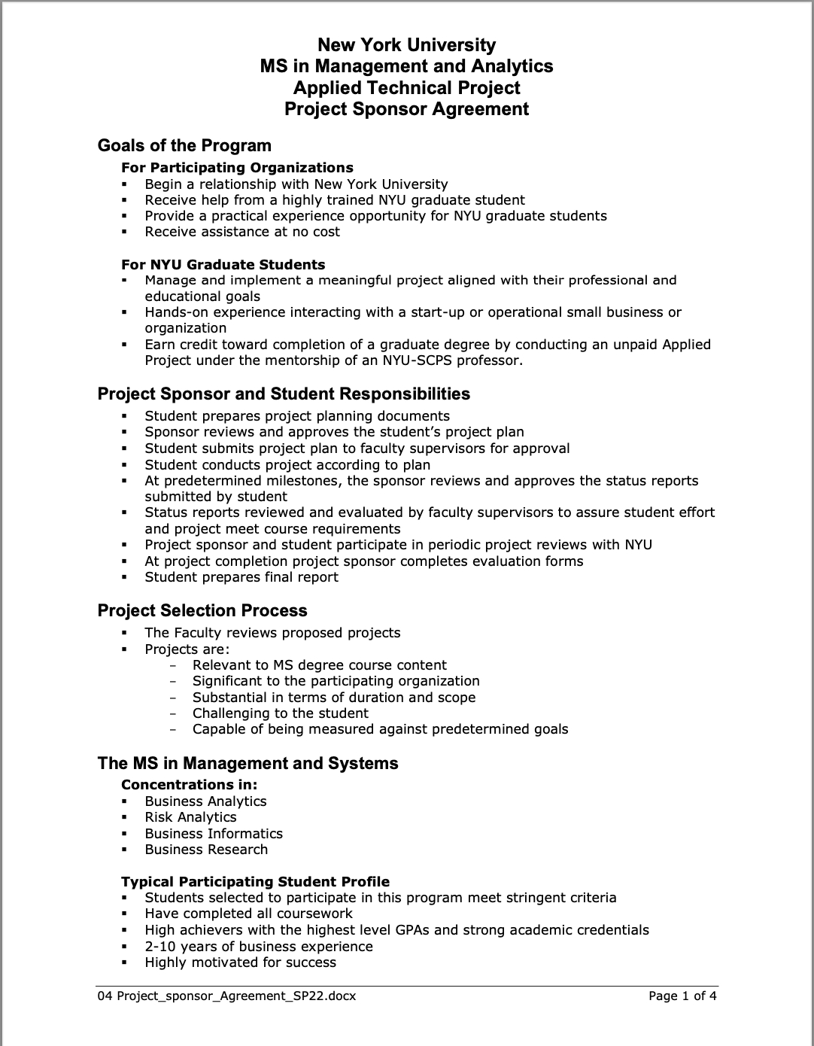

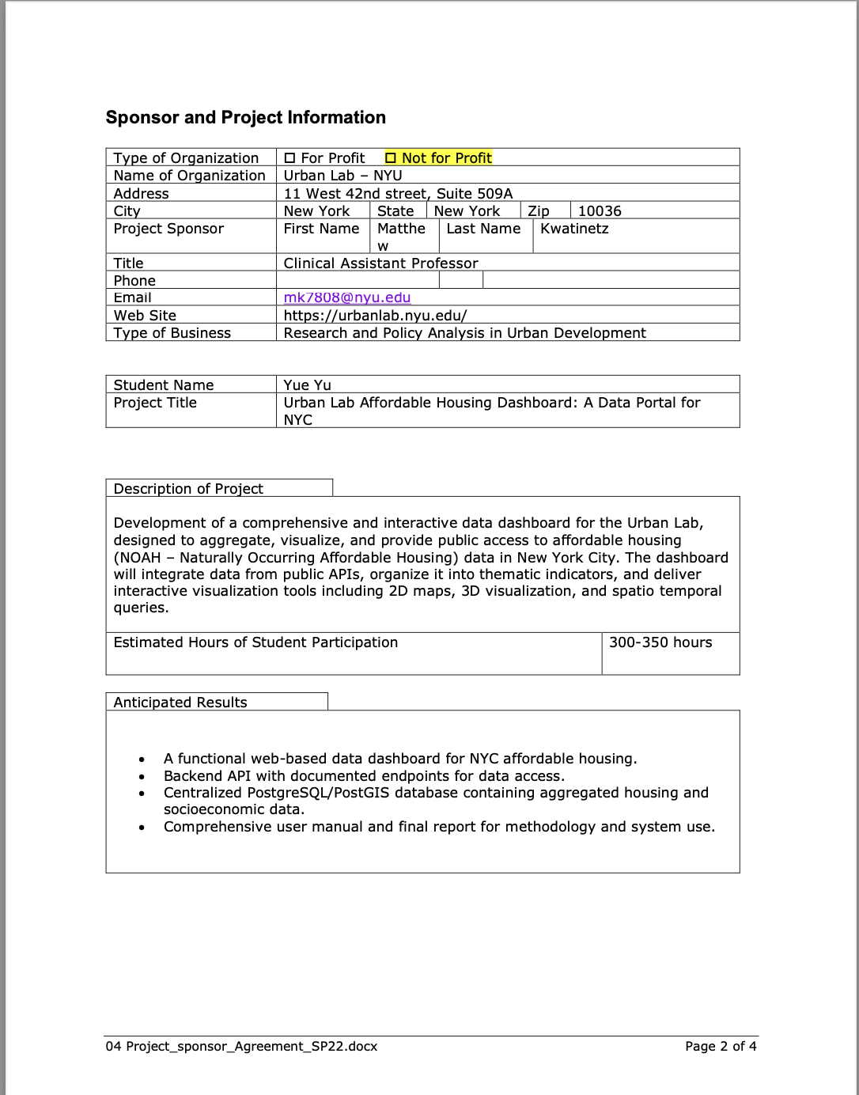





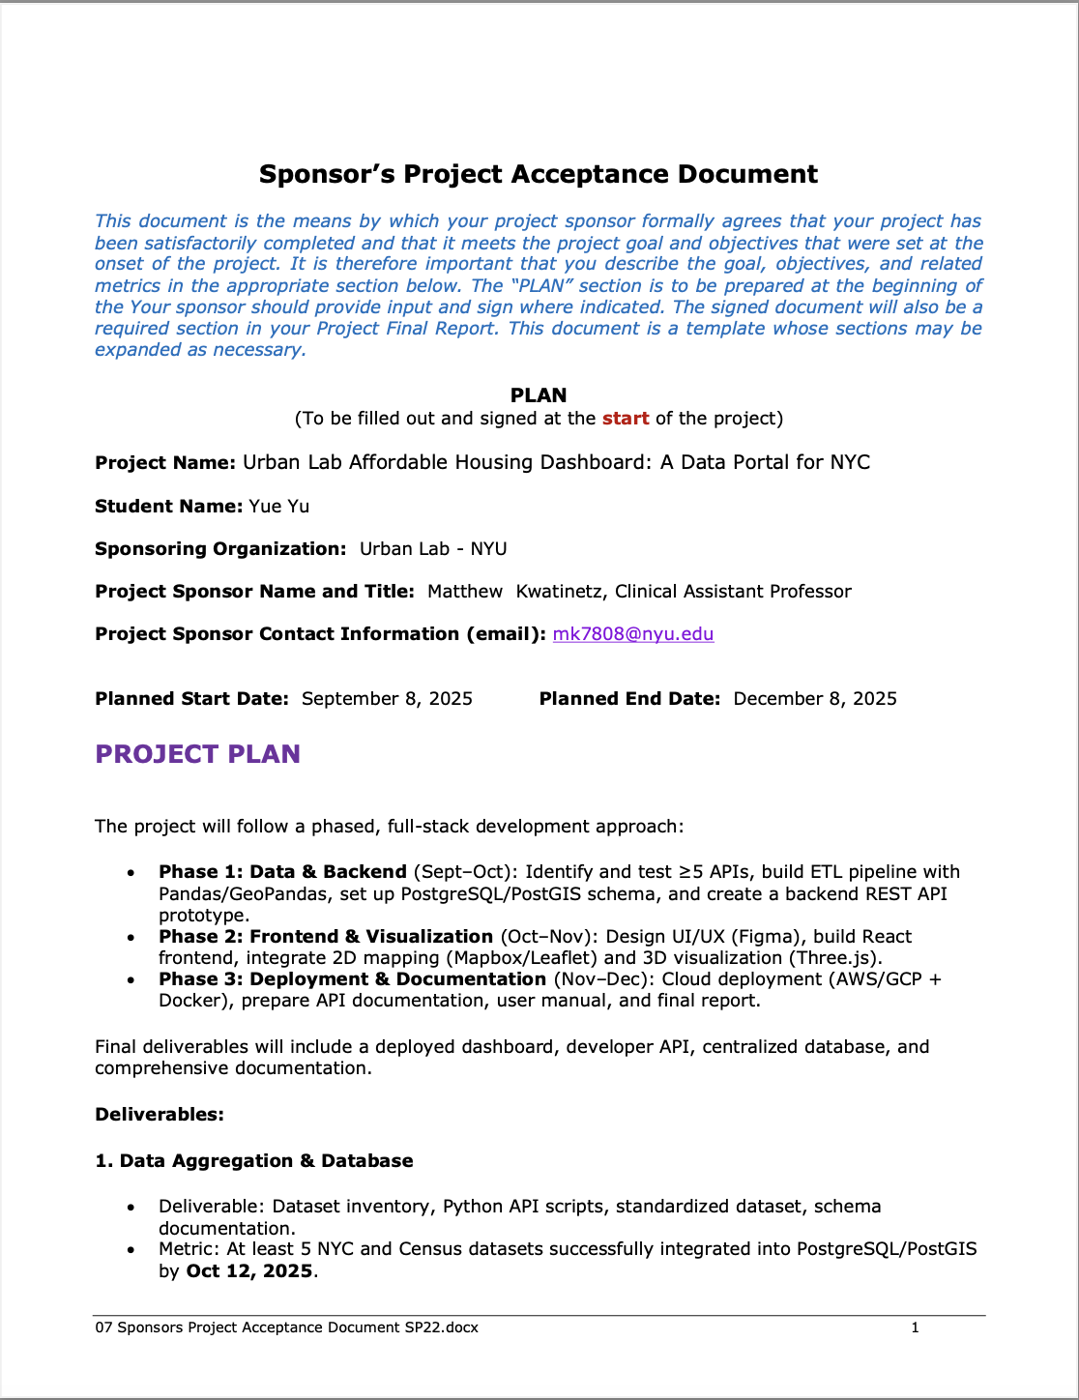



# Appendix C – Functional Requirements Specifications

**Project Goal**

The goal of this project is to develop an integrated data visualization dashboard for the NYU Urban Lab to analyze Naturally Occurring Affordable Housing (NOAH) in New York City. The dashboard will aggregate data from multiple public APIs to create an interactive, accessible, and reusable data resource for researchers, urban planners, and civic stakeholders.

It aims to visualize affordable housing trends, provide tools for spatial and temporal filtering, and allow users to export customized datasets for further analysis. The successful completion of this project will be demonstrated through a stable dashboard that accurately displays NOAH data, supports interactive mapping and data export, and meets the satisfaction and approval of the project supervisors, Thomas and Cameron, for formal delivery to the Urban Lab.

**Project Objectives**

The project will be developed and refined through four clear and measurable phases. Each phase has specific objectives, measurable outcomes, and defined completion dates.

**Phase 1: Minimum Viable Product (MVP) Development**  
The first phase focuses on establishing a functional prototype that connects the front end, back end, and a single database. The Streamlit framework will be used to build an interactive dashboard displaying NOAH data from NYC Open Data. A Flask or FastAPI backend will support data retrieval and communication between layers.  
The metric for success in this phase is a functioning MVP that stably displays sample NOAH data with full front-end and back-end integration. This milestone was completed prior to **October 5, 2025.**

**Phase 2: Data Aggregation and Expansion**  
The second phase will enhance the dashboard by integrating additional data sources to broaden its analytical scope. At least three NYC public APIs, such as ZOLA, ACRIS, and the U.S. Census, will be incorporated. Python with Pandas and GeoPandas will be used for automated cleaning, standardization, and transformation of data, along with scripts to automate regular updates.  
The metric for success is the successful visualization of integrated multi-source data within the dashboard and the establishment of an automated data refresh process. The expected completion date is **October 31, 2025.**

**Phase 3: Functional and Interaction Optimization**  
The third phase focuses on improving user experience and interface functionality. The dashboard will provide multi-criteria filtering, including borough, street, amenities, and project year. It will also allow users to export filtered data in CSV format with customizable columns.  
The metric for success is that users can filter data and export accurate results efficiently, with a loading time of less than three seconds. The expected completion date is **November 20, 2025.**

**Phase 4: Documentation and Final Delivery**  
The final phase includes comprehensive testing, documentation, and formal submission of the completed system to the supervisors. This will include preparing a detailed user manual and API reference, conducting system validation, and resolving any issues identified during review.  
The metric for success is final approval from supervisors Thomas and Cameron upon reviewing the delivered system, which will include the working dashboard, complete documentation, and supporting materials. The expected completion period is from November 20 through **early December 2025.**

**Requirements Specifications**

The Urban Lab Affordable Housing Dashboard will include several functional modules designed to achieve the objectives described above.

1. **User Interface (UI)**  
   A Streamlit-based interactive dashboard will provide access to key functions, including the home page, map visualization, data browser, and a data dictionary page. Users will be able to filter data, explore visualizations, and view thematic insights.
2. **Data Aggregation Module**  
   This module will automatically retrieve data from public APIs and transform it into standardized formats suitable for analysis. Data updates can be performed periodically or on demand.
3. **Database Module**  
   A PostgreSQL database with the PostGIS extension will manage all spatial and tabular datasets. It will store affordable housing indicators and metadata in a structure optimized for geospatial queries.
4. **Mapping and Visualization Module**  
   The dashboard will include interactive 2D map visualizations built using Leaflet or Mapbox, allowing users to view affordable housing distributions, filter by attributes, and inspect details via pop-up windows.
5. **Filtering and Query Module**  
   Users will be able to filter data by location, project characteristics, and other relevant criteria. Common filters will include borough, street, project year, and building amenities.
6. **Export Module**  
   Users will have the ability to export selected datasets in CSV format. They can choose specific columns to include in the export file, such as building ID, rent, and total units.
7. **API Service Module**  
   The system will provide RESTful API endpoints for external researchers to access standardized datasets in JSON format. Authentication will be handled through secure token mechanisms.
8. **Security and Privacy**  
   All data transfers will comply with the NYC Open Data License and follow general principles of data privacy and security, including encrypted communication and controlled access.
9. **Optional Module: 3D Urban Visualization**  
   A three-dimensional visualization feature may be developed as an optional enhancement to display urban structures and related metrics. This module is not part of the current core deliverables but can be integrated in future iterations.

**Use Case**

**Scenario 1: Tenant User (Emily)**  
Emily is a tenant searching for affordable housing opportunities in New York City. After logging into the dashboard, she navigates to the interactive map view. She enters her preferred location in Manhattan Midtown by specifying a street and avenue. The system automatically centers the map on the area and highlights affordable housing options nearby. Emily applies additional filters such as buildings with in-unit laundry and properties less than ten years old. The dashboard retrieves matching records and updates the map to show these locations. It also displays rental trend charts for the selected area. Emily exports the results as a CSV file, including the housing ID and selected columns, to compare listings and track her housing search.

**Scenario 2: Researcher User (Daniel)**  
Daniel is a researcher studying affordable housing policies in New York City. He uses the dashboard to analyze projects initiated between 2015 and 2025. After selecting the project year range and region of interest, the map updates to display all relevant housing projects. Each marker on the map includes information such as project name, number of units, and developer details. Daniel exports the filtered dataset as a CSV file for further analysis in statistical software. The system ensures that exported fields match the applied filters, maintaining consistency between the visualized and exported data.

**Documentation of LLM Prompts**

Part of this document, including the structure of the requirements specifications and the organization of the use case section, was generated with assistance from a large language model (OpenAI GPT-5). The author described the project logic, provided reference materials, and requested a reformulated and standardized version suitable for submission. All AI-assisted content was subsequently reviewed and edited manually to ensure accuracy and alignment with project intentions.

# Appendix D - Project Plan

**Project Tasks Outline**

This project develops a comprehensive and interactive data dashboard that aggregates and visualizes affordable housing data in New York City (NOAH – Naturally Occurring Affordable Housing). It combines public data APIs, spatial visualization, and database integration to support urban researchers, planners, and civic stakeholders. The project runs from **September 1 – December 15, 2025**.

## ****1. Work Breakdown Structure****

### ****Level 1 – Major Milestones****

|  | **Milestone** | **Start – End Dates** | **Deliverable** |
| --- | --- | --- | --- |
| 1 | Project Initiation and Planning | Sep 1 – Sep 15 | Project scope statement and timeline approved |
| 2 | Data Acquisition and Backend Setup | Sep 16 – Oct 5 | Database schema (PostgreSQL/PostGIS) and ETL pipeline ready |
| 3 | Frontend and Visualization Development | Oct 6 – Nov 10 | Functional React dashboard and interactive map |
| 4 | Testing and Technology Trial | Nov 11 – Nov 28 | ETL trial results and UAT completed |
| 5 | Deployment and Documentation | Nov 29 – Dec 15 | Final dashboard deployed with report and manual |

### ****Level 2 – Tasks under Each Milestone****

#### ****1. Project Initiation and Planning (Sep 1 – Sep 15)****

1.1 Define project scope and deliverables  
1.2 Confirm datasets and APIs from NYC Open Data, Census, and HPD  
1.3 Create initial Gantt schedule and assign resources  
1.4 Milestone: Sponsor approval of project plan (Sep 15)

#### ****2. Data Acquisition and Backend Setup (Sep 16 – Oct 5)****

2.1 Design PostgreSQL/PostGIS database schema  
2.2 Develop Python ETL scripts (Pandas + GeoPandas) for data aggregation  
2.3 Load and validate sample datasets (HPD Affordable Housing, 311 Complaints, Census)  
2.4 Integrate API connections and data dictionary  
2.5 Milestone: Backend ETL pipeline operational (Oct 5)

#### ****3. Frontend and Visualization Development (Oct 6 – Nov 10)****

3.1 Design UI/UX in Figma based on DePaul and CUSP models  
3.2 Implement React frontend components and navigation  
3.3 Develop Leaflet/Mapbox 2D map and multi-layer visualization  
3.4 Integrate 3D visualizer (Three.js) for building models  
3.5 Link frontend with backend API for real-time queries  
3.6 Milestone: Interactive map and indicator dashboard functional (Nov 10)

#### ****4. Testing and Technology Trial (Nov 11 – Nov 28)****

4.1 Execute automated vs manual ETL trial (Technology Trial Plan)  
4.2 Conduct unit and integration tests for backend API and UI components  
4.3 Collect performance metrics (update time and error rate)  
4.4 Run User Acceptance Testing (UAT) with Urban Lab team  
4.5 Milestone: Trial results validated and UAT sign-off (Nov 28)

#### ****5. Deployment and Documentation (Nov 29 – Dec 15)****

5.1 Deploy dashboard to cloud (AWS or GCP) using Docker containers  
5.2 Finalize API documentation and user manual  
5.3 Prepare final capstone report and presentation slides  
5.4 Milestone: Project handover and final presentation (Dec 15)

### ****Level 3 – Selected Sub-Tasks (Examples)****

**2.2 Develop ETL scripts:**  
2.2.1 Connect to NYC Open Data APIs  
2.2.2 Implement data cleaning and schema standardization  
2.2.3 Schedule automated loads with cron jobs

**3.3 Leaflet/Mapbox Development:**  
3.3.1 Add layer controls for housing stock and complaints  
3.3.2 Enable geo-filter and time-slider functions  
3.3.3 Test map performance and load times

**4.1 Technology Trial:**  
4.1.1 Run baseline manual data update tests  
4.1.2 Execute automated ETL trial and record metrics  
4.1.3 Analyze results with paired t-test and visuals

## ****2. Time Allocation Summary****

| **Phase** | **Duration** | **Approx. Effort (hours / week)** | **Total Hours** |
| --- | --- | --- | --- |
| 1. Project Initiation & Planning | Sep 1 – Sep 15 | 10 | 20 |
| 2. Data Acquisition & Backend Setup | Sep 16 – Oct 5 | 15 | 45 |
| 3. Frontend & Visualization Development | Oct 6 – Nov 10 | 18 | 90 |
| 4. Testing & Technology Trial | Nov 11 – Nov 28 | 15 | 45 |
| 5. Deployment & Documentation | Nov 29 – Dec 15 | 12 | 36 |
| **Total Estimated Hours** |  |  | **236 hrs** |

## ****3. LLM Prompt Documentation****

**Prompt Used:**

“Generate a three-level Work Breakdown Structure (WBS) for the Urban Lab Affordable Housing Dashboard: A Data Portal for NYC capstone project, using the Technology Trial Plan as the mid-term testing phase. The project runs from September 1 to December 15 2025. Include milestones, sub-tasks, time allocation, and document the prompt per the MASY GC-4100 rubric.”

**LLM Contribution:**  
The large-language-model (LLM) was used to structure milestones, align time frames with the Technology Trial Plan, and ensure rubric compliance. All final task details and sequencing were verified and refined by the author.

# Appendix E - Risk Management Plan

**Project Overview:**

Urban Lab Affordable Housing Dashboard: A Data Portal for NYC  
This project develops an interactive web-based dashboard integrating NYC affordable housing data from multiple public APIs. It combines backend data aggregation, a spatial database, and frontend visualizations to support urban research and decision-making.

**Total project time budget: 100 hours.**

**Risk Identification**

|  |  |  |  |
| --- | --- | --- | --- |
| **Number** | **Risk** | **Probability Score (1,2 or 3)** | **Impact Score (1,2 or 3)** |
| 1 | Public API structure or endpoints change, breaking automated data ingestion. | 3 | 3 |
| 2 | Data inconsistency or missing fields among different NYC datasets causes integration errors. | 2 | 3 |
| 3 | Backend Flask server or PostgreSQL connection failure interrupts data access. | 2 | 2 |
| 4 | Spatial query or PostGIS configuration errors produce incorrect map results. | 2 | 2 |
| 5 | Cloud hosting or deployment environment misconfiguration causes downtime. | 2 | 3 |
| 6 | Frontend React map layers fail to load due to API rate limits or script errors. | 2 | 2 |
| 7 | System performance issues (slow response, high memory use) degrade user experience. | 3 | 2 |
| 8 | Lack of adequate version control or backup leads to code loss or rollback delays. | 2 | 2 |
| 9 | Limited time (100 hours) results in incomplete implementation of planned features. | 3 | 3 |
| 10 | Delays in feedback or communication with the supervisor postpone testing and delivery. | 2 | 3 |

**Risk Matrix**

This matrix places each risk (using the same numbering from the first table) into the appropriate probability–impact cell.

|  |  |  |  |  |
| --- | --- | --- | --- | --- |
|  | RISK (exposure) | | | |
| Probability (of occurrence) |  | 1.Slight | 2. Moderate | 3. High |
| 1. Very Unlikely |  |  |  |
| 2. Possible |  | Risk 3,4,6,8 | Risk 2,5,10 |
| 3. Expected |  | Risk 7 | Risk 1,9 |

**Contingency Plan**

The red-zone risks are: **1, 2, 5, 9, and 10** (all with exposure score 3×3 or 2×3).  
The following contingency strategies were created:

|  |  |  |  |  |
| --- | --- | --- | --- | --- |
| No. | Risk Description | Probability | Exposure | Contingency Plan |
| 1 | Public API structure or endpoints change, breaking automated data ingestion. | 3 | 3 | Develop a backup schedule to regularly export static CSVs; create a versioned API connector and update script within 24 hours of API change detection. |
| 2 | Data inconsistency or missing fields among different NYC datasets causes integration errors. | 2 | 3 | Build a standardized schema validator to detect missing attributes and automatically flag inconsistent rows for manual review before database upload. |
| 5 | Cloud hosting or deployment environment misconfiguration causes downtime. | 2 | 3 | Maintain a parallel staging server; schedule weekly deployment tests and implement automated alerts for failed builds. |
| 9 | Limited time (100 hours) results in incomplete implementation of planned features. | 3 | 3 | Prioritize core functionality (data ingestion, mapping) before advanced features; maintain a rolling feature backlog for post-capstone improvements. |
| 10 | Delays in feedback or communication with the supervisor postpone testing and delivery. | 2 | 3 | Maintain fixed weekly check-ins; document interim versions; proceed with internal testing during feedback delays. |

## ****Monitoring Plan****

All remaining risks are monitored through weekly progress reviews.  
To minimize probability and limit impact, the project uses:

* Git-based version control
* Frequent database backups
* Structured feature prioritization
* Staged deployment and rollback procedures
* Continuous ETL validation

# Appendix F – Organizational Change Management Plan

1. **Objective Clarification**

**Vision:**

The Urban Lab NOAH Dashboard aims to integrate diverse affordable housing datasets into a unified, interactive internal portal that enhances research efficiency and data transparency across Urban Lab projects. The system aligns with Urban Lab’s strategic goal of advancing data-driven urban research and supporting evidence-based policy analysis.

**Key Outcomes:**

Success will be measured by (1) full deployment of the dashboard with API-based data integration from at least 10 sources; (2) a >40% reduction in manual data collection time for researchers; (3) consistent data access and visualization for all project members; and (4) a standardized internal workflow for future data-driven projects.

1. **Stakeholder Engagement**

**Identify Stakeholders:**

Key stakeholders include Urban Lab researchers, data engineers, project managers, and affiliated NYU faculty who will directly use and maintain the dashboard. Indirect stakeholders include student assistants and partner institutions that contribute datasets or collaborate on analysis.

**Communication Plan**:

Project communication will be managed through internal meetings and shared digital workspaces (e.g., Teams, Slack, or Notion). The dashboard itself will act as the main hub for updates, documentation, and version tracking, allowing all team members to access current data and project information as needed.

1. **Cultural Assessment and Planning Section**

**Current Culture Analysis:**

Urban Lab has a strong culture of research collaboration and innovation but currently relies on dispersed data management practices and manual processes. This fragmentation limits efficiency and slows project turnaround.

**Desired Culture Definition*:***

The dashboard initiative seeks to cultivate a data-driven culture emphasizing shared standards, collaboration, and automation. It promotes consistent use of centralized digital tools to strengthen project transparency and knowledge sharing within the Lab.

1. **Change Management Section**

**Change Model Adoption:**

The project follows **Kotter’s 8-Step Model**, focusing on creating urgency around the inefficiencies of fragmented data, building a guiding coalition among research leads, communicating the shared vision for streamlined workflows, and reinforcing adoption through demonstrated time savings and improved data accuracy.

**Resistance Management:**

Resistance may arise from staff accustomed to traditional manual data handling. To address this, early training, open Q&A sessions, and clear demonstration of the dashboard’s efficiency benefits will be implemented. Feedback will be incorporated iteratively to ensure staff confidence and ownership of the new system.

1. **Skills and Capability Enhancement Section**

**Skills Inventory:**

Current team skills include GIS analysis, Python-based data processing, and housing research expertise. Skill gaps exist in database administration, API configuration, and version control management.

**Training and Development:**

Training sessions will be conducted internally to enhance familiarity with PostgreSQL/PostGIS, API documentation practices, and front-end data visualization. Experienced developers will mentor new members, ensuring sustainable skill transfer and system maintenance capability.

1. **Documentation and Communication Section**

**Process Documentation:**

All development stages, from planning to testing, will be logged in a shared Confluence or GitHub repository. Documentation will include data dictionaries, schema diagrams, change logs, and troubleshooting records to ensure reproducibility and transparency across future research cycles.

**Feedback Mechanisms:**

User feedback will be collected through short internal surveys and regular debrief meetings. Identified issues or feature requests will be prioritized in agile sprints, ensuring continuous improvement based on researcher experience.

1. **Integration and Adaptation Section**

**Scalability Plan:**

Once fully adopted within Urban Lab, the dashboard will be extended to support additional research projects and potential collaboration with other NYU labs. The backend structure (PostGIS and Flask API) allows seamless integration of new datasets or modules with minimal reconfiguration.

**Continuous Improvement:**

The project team will maintain quarterly review cycles to evaluate data freshness, usability, and performance metrics. Feedback-driven iterations will ensure the platform evolves with research needs and technological advances.

**PROMPTS**

**Tool Used:** ChatGPT (GPT-5, OpenAI).

**Process and Prompts:**

1. Uploaded the following reference documents:  
   – Urban Lab Affordable Housing Dashboard: A Data Portal for NYC (Project Proposal)  
   – Briefing on Creating an Organizational Change Plan (Fortino, 2024)  
   – The Organizational Change Plan FA24 (Reference Guide)  
   – MSMA GC-4115 Organizational Change Plan Briefing Template FA25 (Submission Template)
2. Prompt to AI: “Generate an internal Organizational Change Management Plan for the Urban Lab Affordable Housing Dashboard, using the FA25 template and rubric, with Kotter’s 8-Step Model and focus on internal adoption within Urban Lab.”
3. Reviewed and revised to align tone and scope with internal implementation context.

# Appendix G – Technology Trial Plan

**Business Task and Objectives**

Improve the efficiency and reliability of data aggregation and visualization for NYC affordable-housing datasets by automating data collection and enabling dynamic map-based exploration.

**The Hypothesis**

* Population: Urban Lab researchers and dashboard users.
* Intervention: Automated ETL pipeline (Python + PostgreSQL/PostGIS) replacing manual CSV uploads.
* Control: Manual data updates and static Excel-based visualization.
* Expected Outcome: Faster data updates and higher accuracy in dataset integration.

Hypothesis Statement:

By introducing an automated data-pipeline using Python and PostgreSQL/PostGIS, the data-update time will decrease by at least 50% (from baseline mean T₀ to ≤ 0.5T₀) and data integration accuracy will improve by 20% compared with manual processing over a two-week trial period.

**Baseline Metrics and Control Group**

Measure current manual workflow:

* Average update time per dataset (hours).
* Error rate from manual joins (%).  
  Keep the manual process unchanged as the control group for comparison with the automated pipeline.  
  Metrics such as processing time and error rate will be recorded **daily** during both the baseline and intervention phases to ensure consistency.

**The Trial**

• **Duration:** Two weeks (Nov 13 – Nov 28).

• **Metrics:** Processing time and error rate between manual vs automated methods.

• **Comparison Plan:** Run both methods on identical datasets and compare mean differences using a paired t-test and exploratory data analysis.

Results will be summarized in visual comparison charts and summary tables to clearly show performance differences.

**The Technology**

Python ETL script (Pandas + GeoPandas) connected to PostgreSQL/PostGIS to automate data download, cleaning, and insertion from NYC Open Data APIs.

**Data Collection**

Record time logs and error counts for each dataset load. Store results in a CSV table with the following structure:

* dataset_id (string)
* method (categorical: manual / automated)
* load_time (float, minutes)
* error_rate (float, %)
* timestamp (datetime)

**Data dictionary:** Describes each field’s data type, range, and meaning to ensure data consistency.

**Analysis of Results**

Compare averages for load_time and error_rate between control and intervention groups. Conduct descriptive EDA and paired t-test. Visualize results with bar charts.

**Findings and Recommendations**

If automated pipeline shows significant improvement, recommend full integration into dashboard architecture and documentation for Urban Lab team. Otherwise, adjust scripts for data validation before retesting.

**Documentation of LLM use**

Prompts used: ‘Generate a Technology Trial Plan for Urban Lab Affordable Housing Dashboard using automated ETL pipeline as intervention.’

# Appendix H - Status Reports

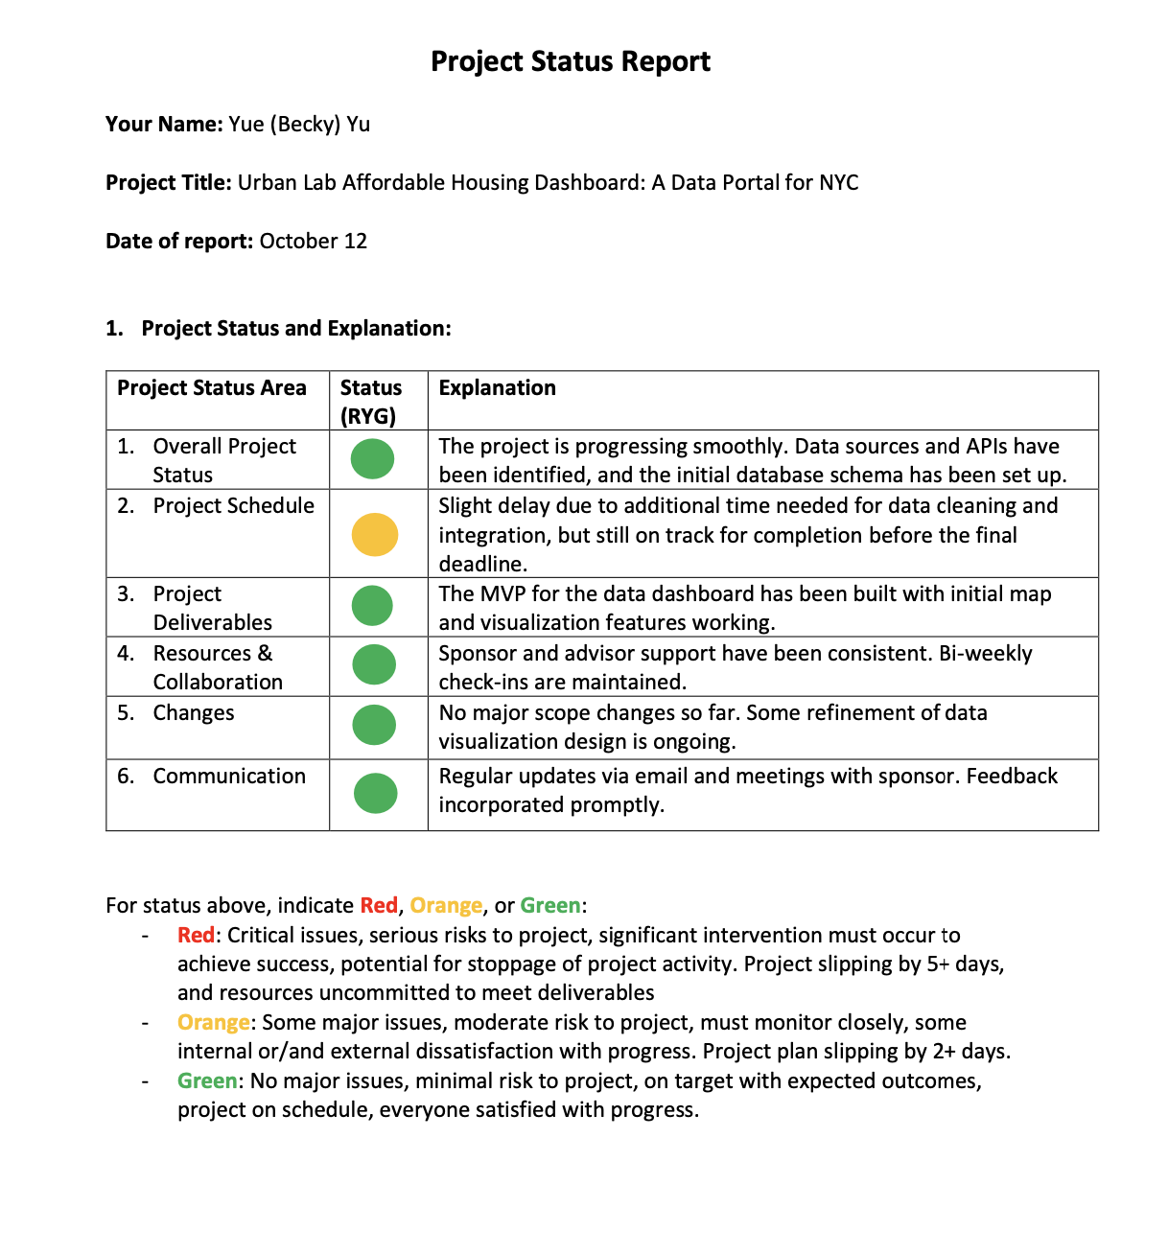



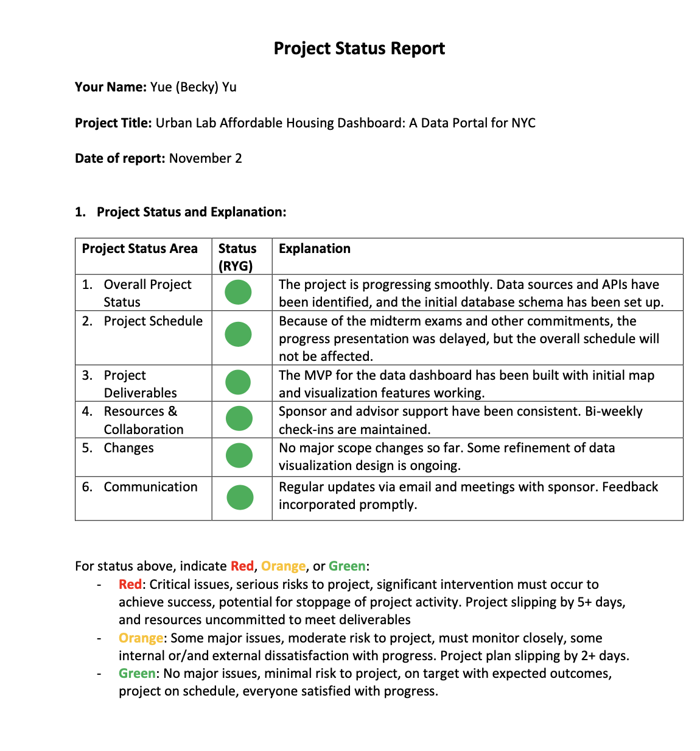

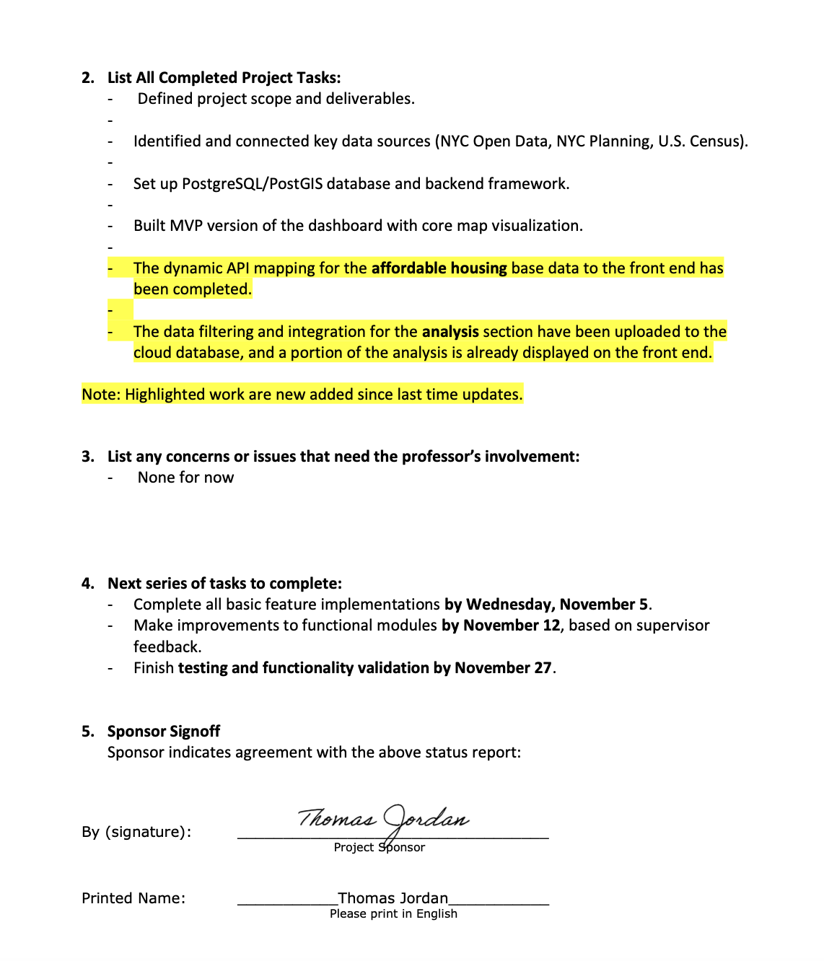

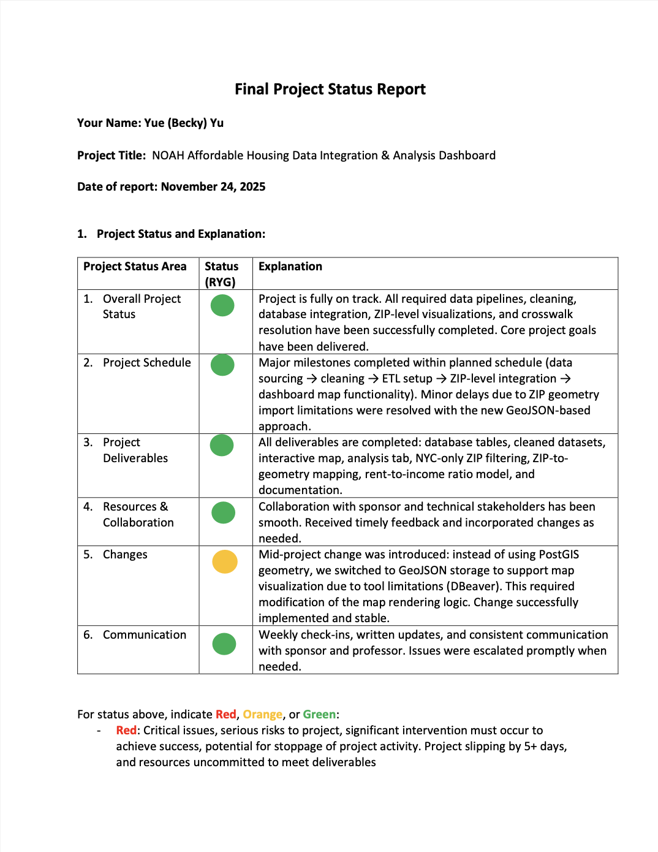

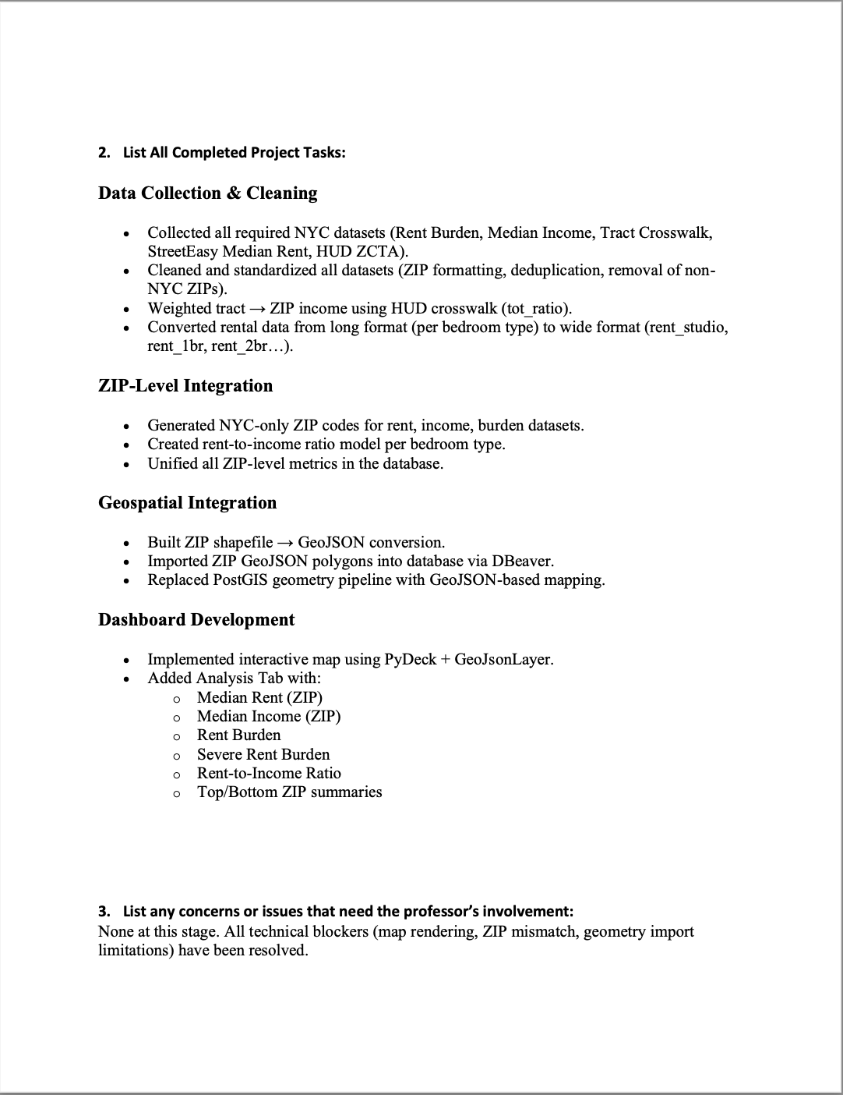

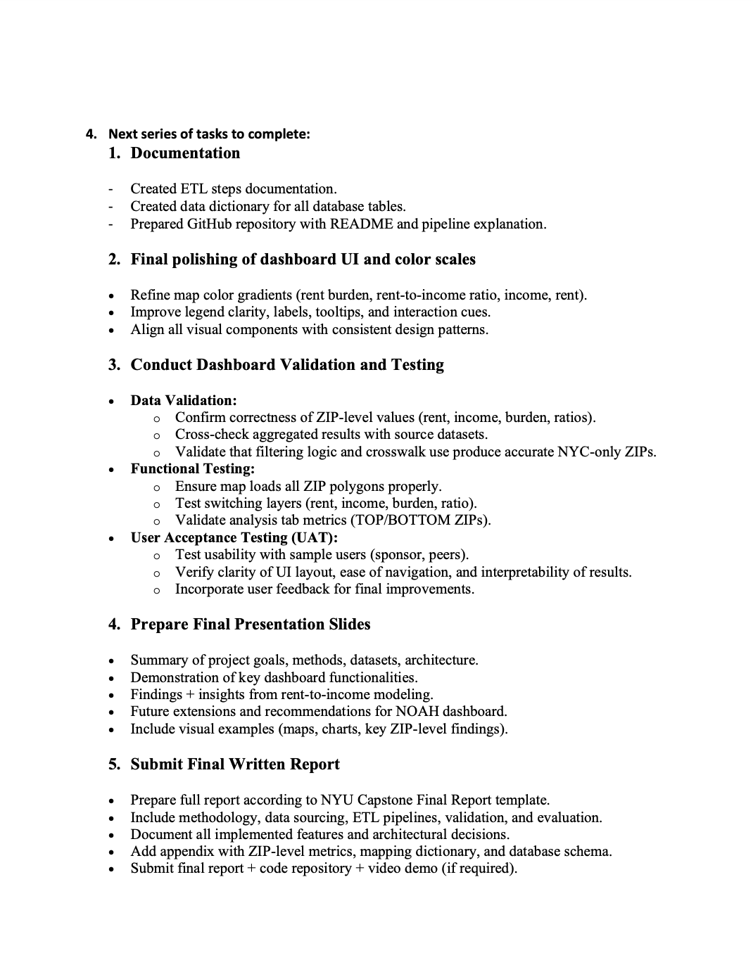

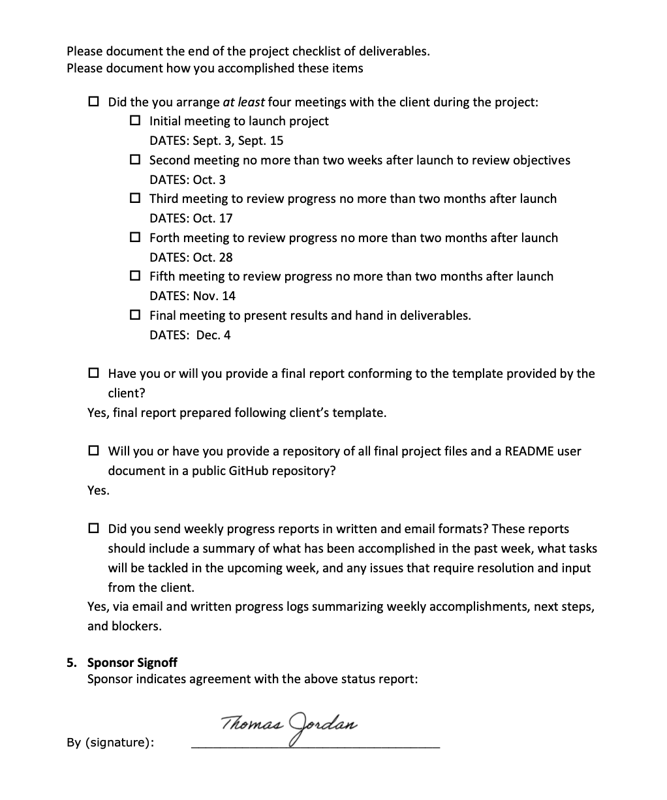



# Appendix I - Annotated Bibliography

1. Ambrose, B. W., Coulson, N. E., & Yoshida, J. (2015). The repeat rent index. Review of Economics and Statistics, 97(5), 939–950.  
   **Ranking:** A  
   **Abstract:** We employ a weighted repeat rent estimator to construct quarterly indexes that expand the profession's ability to make cross-sectional comparisons of housing markets. Our analysis shows that there is considerable heterogeneity in the behavior of rents across cities over the 2000-2010 decade, but the number of cities and years for which nominal rents fell is substantial; rents fell in many cities following the onset of the housing crisis in 2007; and the repeat rent and Bureau of Labor Statistics indexes differ due to sampling and construction methods.  
   **ChatGPT provided summary:** This article develops a repeat rent index that tracks the same unit across time to control for quality and composition. The approach offers a credible way to measure rental price change and to compare with hedonic methods.  
   **Researcher comments:** I will cite this as the measurement foundation for Market Rent notes. It supports explaining why simple medians need caveats about composition and quality.
2. Boeing, G., & Waddell, P. (2017). New insights into rental housing markets across the United States: Web scraping and analyzing Craigslist rental listings. Journal of Planning Education and Research, 37(4), 457–476.  
   **Ranking:** A  
   **Abstract:** Current sources of data on rental housing—such as the census or commercial databases that focus on large apartment complexes—do not reflect recent market activity or the full scope of the US rental market. To address this gap, we collected, cleaned, analyzed, mapped, and visualized eleven million Craigslist rental housing listings. The data reveal fine-grained spatial and temporal patterns within and across metropolitan housing markets in the United States. We find that some metropolitan areas have only single-digit percentages of listings below fair market rent. Nontraditional sources of volunteered geographic information offer planners real-time, local-scale estimates of rent and housing characteristics currently lacking in alternative sources, such as census data.  
   **ChatGPT provided summary:** The authors present a complete workflow for collecting and cleaning listing data, including deduplication, geocoding, and screening of outliers. They discuss biases and ethics and show how asking rent can be used as a timely market signal.  
   **Researcher comments:** I will use this as the main reference for constructing and labeling asking-rent indicators and for the caveats in the map legend.
3. Colburn, G., & Allen, R. (2018). Rent burden and the Great Recession in the USA. Urban Studies, 55(10), 2265–2285.  
   **Ranking:** A  
   **Abstract:** In the aftermath of the recent recession, the percentage of households facing rent burden in the USA reached historically high levels, while cost burden for owners has shrunk. This study uses two panels from the Survey of Income and Program Participation (SIPP) to compare the prevalence, distribution and household responses to the phenomenon of rent burden in the USA in the years immediately before and after the Great Recession. Results suggest that rent burden has become more prevalent after the recession and that income, household composition and location are major drivers of this phenomenon, both before and after the recession. Results also indicate that exiting rent burden was more difficult in the years after the recession and that an increasingly common coping mechanism for rent burdened households is to increase their household sizes. These results indicate that renters have experienced increased financial stress related to their housing. This finding is notable given the lack of policy responses that address hardship among renter households in contrast to the privileged status enjoyed by homeowners in the policy domain.  
   **ChatGPT provided summary:** The study examines cost burden before, during, and after the Great Recession. It documents persistent increases and heterogeneous impacts across metropolitan areas and households.  
   **Researcher comments:** This supports using the 30 percent and 50 percent thresholds and motivates showing burden distributions at tract or community district scale.
4. Desmond, M., & Wilmers, N. (2019). Do the poor pay more for housing? American Journal of Sociology, 125(3), 1093–1150.  
   **Ranking:** B  
   **Abstract:** This article examines tenant exploitation and landlord profit margins within residential rental markets. Defining exploitation as being overcharged relative to the market value of a property, the authors find exploitation of tenants to be highest in poor neighborhoods. Landlords in poor neighborhoods also extract higher profits from housing units. Property values and tax burdens are considerably lower in depressed residential areas, but rents are not. Because landlords operating in poor communities face more risks, they hedge their position by raising rents on all tenants, carrying the weight of social structure into price. Since losses are rare, landlords typically realize the surplus risk charge as higher profits. Promoting a relational approach to the analysis of inequality, this study demonstrates how the market strategies of landlords contribute to high rent burdens in low-income neighborhoods.  
   **ChatGPT provided summary:** The article analyzes rents relative to property values and risk. It argues that disadvantaged renters often face higher effective prices due to segmentation and constraints.  
   **Researcher comments:** I will use this to interpret spatial disparities in rent burden when market rent levels alone do not explain observed burdens.
5. Fields, D., & Uffer, S. (2014). The financialisation of rental housing: A comparative analysis of New York City and Berlin. Urban Studies, 53(7), 1486–1502.  
   **Ranking:** B  
   **Abstract:** This paper compares how recent waves of private equity real estate investment have reshaped the rental housing markets in New York and Berlin. Through secondary analysis of separate primary research projects, we explore financialisation's impact on tenants, neighbourhoods, and urban space. Despite their contrasting market contexts and investor strategies, financialisation heightened existing inequalities in housing affordability and stability, and rearranged spaces of abandonment and gentrification in both cities. Conversely cities themselves also shaped the process of financialisation, with weakened rental protections providing an opening to transform affordable housing into a new global asset class. We also show how financialisation's adaptability in the face of changing market conditions entails ongoing, but shifting processes of uneven development. Comparative studies of financialisation can help highlight geographically disparate, but similar exposures to this global process, thus contributing to a critical urban politics of finance that crosses boundaries of space, sector and scale.  
   **ChatGPT provided summary:** The study links capital flows and ownership changes to tenant outcomes and the composition of rental stock. It situates NYC within broader financialization trends.  
   **Researcher comments:** I will cite this for Industry and Housing Stock context to explain why NOAH units are vulnerable in appreciating areas.
6. Hankinson, M. (2018). When do renters behave like homeowners? High rent, price anxiety, and NIMBYism. American Political Science Review, 112(3), 473–493.  
   **Ranking:** B  
   **Abstract:** How does spatial scale affect support for public policy? Does supporting housing citywide but “Not In My Back Yard” (NIMBY) help explain why housing has become increasingly difficult to build in once-affordable cities? I use two original surveys to measure how support for new housing varies between the city scale and neighborhood scale. Together, an exit poll of 1,660 voters during the 2015 San Francisco election and a national survey of over 3,000 respondents provide the first experimental measurements of NIMBYism. While homeowners are sensitive to housing’s proximity, renters typically do not express NIMBYism. However, in high-rent cities, renters demonstrate NIMBYism on par with homeowners, despite continuing to support large increases in the housing supply citywide. These scale-dependent preferences not only help explain the deepening affordability crisis, but show how institutions can undersupply even widely supported public goods. When preferences are scale dependent, the scale of decision-making matters.  
   **ChatGPT provided summary:** Survey experiments show that exposure to high housing costs can shift renter attitudes toward development, sometimes resembling homeowner preferences.  
   **Researcher comments:** This helps anticipate community responses and supports a neutral and explanatory tone in the dashboard narrative.
7. Meltzer, R., & Schwartz, A. (2016). Housing affordability and health: Evidence from New York City. Housing Policy Debate, 26(1), 80–104.  
   **Ranking:** A  
   **Abstract:** It is generally understood that households make tradeoffs between housing costs and other living expenses. In this article, we examine the relationship between health-related outcomes and housing-induced financial burdens for renters in one of the most expensive cities in the world, New York, New York. Drawing from the Housing Vacancy Survey for 2011, a representative survey conducted by the U.S. Census Bureau of more than 16,000 households in New York City, we estimate the effect of housing cost burden on the overall health of renters and the extent to which they have postponed various types of medical services for financial reasons. Results show that higher out-of-pocket rent burdens are associated with worse self-reported health conditions and a higher likelihood to postpone medical services for financial reasons. This relationship is particularly strong for those households with severe rent burdens. In addition, housing cost burden is equally or more important than other physical housing characteristics in explaining the variation in self-reported general health status and health care postponement. These findings are robust across specifications with different degrees of household, unit/building, and neighborhood controls, and among longstanding and newer renters. Our findings point to the importance of considering health-related outcomes when designing housing policies, and that housing subsidies should target both renters' out-of-pocket costs and place-based repair and maintenance.  
   **ChatGPT provided summary:** The paper connects rent burden to self-reported health and delayed care in NYC. It underscores the broader significance of affordability as a policy signal.  
   **Researcher comments:** I will cite this as an NYC-specific anchor for rent-burden indicators, without implementing health modules.
8. Favilukis, Jack, et al. Affordable Housing and City Welfare. National Bureau of Economic Research, 2019.  
   **Ranking:** B  
   **Abstract:** Housing affordability is the main policy challenge for many large cities in the world. Zoning changes, rent control, housing vouchers, and tax credits are the main levers employed by policy makers. But how effective are they at combatting the affordability crisis? We build a new framework to evaluate the effect of these policies on the well-being of its citizens. It endogenizes house prices, rents, construction, labor supply, output, income and wealth inequality, as well as the location decisions of households. Its main novel features are risk, risk aversion, and incomplete risk-sharing. We calibrate the model to the New York MSA, incorporating current zoning and affordable housing policies. Housing affordability policies carry substantial insurance value but cause misallocation in labor and housing markets. Housing affordability policies that enhance access to this insurance especially for the neediest households create large net welfare gains.  
   **ChatGPT provided summary:** The working paper evaluates how affordable housing policies affect welfare and population distribution in cities. It provides a model-based perspective on policy mechanisms.  
   **Researcher comments:** I will use this for Housing Stock and policy mechanism background. It will not be used as a direct method in the UI.
9. NYC Department of Housing Preservation and Development. (2025). Area Median Income (AMI) levels and rent limits. New York, NY.  
   Ranking: A  
   **Abstract:** Official HPD guidance document that lists income limits and maximum rents by household size for affordable housing programs in New York City.  
   **ChatGPT provided summary:** The HPD AMI table is the authoritative source defining how income bands are set in NYC. It translates federal HUD AMI levels into city-specific rent limits and eligibility thresholds.  
   **Researcher comments:** I will use this to label income categories and rent limits in the dashboard; ensures our indicators align with official program definitions.
10. NYC Office of the Comptroller. (2024). Spotlight: New York City’s rental housing market. New York, NY.  
    **Ranking:** B  
    **Abstract:** Official analytical report issued by the NYC Office of the Comptroller that reviews recent rental housing trends, affordability metrics, and production data across boroughs.  
    **ChatGPT provided summary:** The report compiles recent trends for rents, vacancy, production, and burden at city and sub-borough levels.  
    **Researcher comments:** I will use this to benchmark levels and trend directions for the dashboard indicators.
11. NYC Rent Guidelines Board. (2025). Income and Affordability Study. New York, NY.  
    **Ranking:** A  
    **Abstract:** This study highlights year-to-year changes in many of the major economic factors affecting NYC’s tenant population and takes into consideration a broad range of market forces and public policies affecting housing affordability, such as unemployment rates; wages; housing court and eviction data; and rent and poverty levels.  
    **ChatGPT provided summary:** The annual study provides authoritative statistics on incomes, rents, and hardship in NYC. It includes methodological appendices and consistent definitions.  
    **Researcher comments:** I will cite this repeatedly for current figures and definitions for rent burden and income bands.
12. NYU Furman Center. (Various years). State of the City: Housing in New York City (Citywide data tables). New York, NY.  
    **Ranking:** B  
    **Abstract:** The State of the City: Housing in New York City series, published annually by the NYU Furman Center, provides a comprehensive overview of housing, land use, demographics, and neighborhood conditions across the five boroughs. Each edition compiles citywide and sub-borough data on affordability, rental trends, homeownership, and new development, offering consistent indicators for longitudinal comparison. The report is a key reference for policymakers, planners, and researchers seeking to understand housing dynamics and socioeconomic disparities in New York City.  
    **ChatGPT provided summary:** This series presents citywide and neighborhood statistics with consistent methods. It is widely used by agencies and researchers.  
    **Researcher comments:** I will use selected tables to validate indicator levels and cross-check definitions.
13. Schwartz, A. (2019). New York City’s housing affordability policies in context. Cityscape, 21(3), 181–198.  
    **Ranking:** A  
    **Abstract:** This article examines the evolution and outcomes of New York City’s affordable housing initiatives since the 1980s, focusing on the constraints of municipal authority, fiscal resources, and land supply. Schwartz argues that while New York City has demonstrated exceptional local commitment and policy innovation, structural and market limitations prevent city policies from fully resolving affordability challenges. The analysis situates local actions within the broader context of federal disinvestment and state-level policy environments.  
    **ChatGPT provided summary:** The review situates NYC’s affordability strategy within fiscal and structural constraints. It clarifies what city tools can and cannot accomplish.  
    **Researcher comments:** I will cite this in the Industry and Problem sections to justify the dashboard’s measurement-first scope.
14. Seymour, E., Endsley, K., & Franklin, R. S. (2020). Differential drivers of rent burden in growing and shrinking cities, 1980–2017. Applied Geography, 122, 102240.  
    **Ranking:** A  
    **Abstract:** Housing affordability is an issue of increasing importance and interest, particularly in the United States. Much of this interest is due to skyrocketing rents in coastal cities with tight housing markets. Shrinking cities, in contrast, are often characterized as rich in low-cost housing, providing an affordable alternative to superstar cities. This paper compares income and rent dynamics in cities with growing versus shrinking populations. While costs may be lower in shrinking cities, falling incomes have likely rendered housing unaffordable for many residents. We employ multiple lines of evidence to test for different dynamics between growing and shrinking cities. Matching is used to explore changes in income and rent between 1980 and 2017 in shrinking and the most similar non-shrinking cities. After controlling for baseline conditions, shrinking cities exhibit faster falling incomes and growing cities exhibit faster rising rents, while rent burden increases at a very similar rate in both groups. We also use a fixed effects regression model to test for differences between growing and shrinking cities in sensitivity of rent burden to changes in income and rent. Rent burden has considerably increased across US cities since 1980, yet growing and shrinking cities exhibit clearly different pathways toward that end. Shrinking cities are more sensitive to identical changes in income and rent, likely because a greater share of their residents live near the edge of affordability. •Housing affordability is a problem of global dimensions, impacting cities throughout the developed world.•Rent burden has increased across U.S. cities since 1980, yet growing and shrinking cities exhibit different rent and income dynamics.•Shrinking cities exhibit faster falling incomes while growing cities exhibit faster rising rents.•Shrinking cities are also more sensitive to identical changes in income and rent, as a greater share of residents likely live near the edge of affordability.  
    **ChatGPT provided summary:** The authors separate the roles of rent growth and income change in shaping burden across different urban trajectories. They provide long-run evidence on determinants of burden.  
    **Researcher comments:** I will use this to interpret changes in rent-burden charts and to write notes about rent versus income contributions.
15. Sieg, H., & Yoon, C. (2019). Waiting for affordable housing in New York City. Quantitative Economics, 11(1), 183–217.  
    **Ranking:** A  
    **Abstract:** We develop a new dynamic equilibrium model with heterogeneous households that captures the most important frictions that arise in housing rental markets and explains the political popularity of affordable housing policies. We estimate the model using data collected by the New York Housing Vacancy Survey in 2011. We find that there are significant adjustment costs in all markets as well as serious search frictions in the market for affordable housing. Moreover, there are large queuing frictions in the market for public housing. Having access to rent-stabilized housing increases household welfare by up to $65,000. Increasing the supply of affordable housing by ten percent significantly improves the welfare of all renters in the city. Progressive taxation of higher-income households that live in public housing can also be welfare improving.   
    **ChatGPT provided summary:** This paper models search and waiting in NYC affordable housing allocation. It shows why access frictions are central to outcomes. in access.  
    **Researcher comments:** I will cite this when introducing access indicators and when explaining that we avoid heavy modeling in the UI.
16. Zapatka, S., de Castro, A. M., & Galvão, J. C. (2023). Affordable regulation? New York City rent stabilization as housing affordability policy. City & Community, 22(4), 884–908.  
    **Ranking:** A  
    **Abstract:** The growing housing affordability crisis is at the center of conversations about U.S. inequality. This paper reconsiders the role of rent stabilization as one important affordability tool. We investigate who is most likely to benefit from rent stabilization, how much non-stabilized renters would save if their units were stabilized, and the extent to which stabilization would reduce rent burden among households. Using New York City Housing Vacancy Survey data and employing logistic and hedonic regression techniques, we show that Hispanic and foreign-born householders are more likely to live in rent-stabilized units and find evidence of both rent savings and rent burden reduction when comparing stabilized tenants with their non-stabilized counterparts. We argue that expanded rent stabilization could be paired with policies that stimulate new construction to simultaneously curb rent inflation, protect current populations from displacement, and increase housing supply.  
    **ChatGPT provided summary:** The study evaluates how rent stabilization affects affordability outcomes and who benefits. It includes discussion of demographic differences in access.  
    **Researcher comments:** I will use this to interpret observed burden patterns in neighborhoods with a high share of stabilized units.